COTS Components Aurora

1 General Information 6
1.1 Document scope, ownership and responsibility 6
1.2 Component short description 6
1.3 Reasons for development 7
1.4 Usage and position in vehicle 7
1.5 Variants 9
1.6 Geometrical limitations or Interfaces 9
1.6.1 Interfaces – Design review 9
1.7 Supplier Drawings 9
1.7.1 General 2D Drawing Requirements 10
1.7.2 Criticality 10
1.8 Functions 10
1.9 General test conditions 10
1.9.1 Evidence of test results 12
1.10 Verification overview 13
1.10.1 Test sequence 13
1.10.2 Test report content 13
1.11 Test preparations 14
1.11.1 Initial and final status of component 14
1.11.1.1 Initial function test, normal climate 15
1.11.1.2 Initial function test, cold climate 15
1.11.1.3 Initial function test, hot climate 15
1.11.1.4 Final function test, normal climate 15
1.11.1.5 Final function test, cold climate 15
1.11.1.6 Final function test, hot climate 15
1.11.1.7 Post-test analysis 15
1.11.2 Monitoring 15
1.11.2.1 Monitoring – Design review 16
2 Quality and Uptime 16
2.1 Reliability/Durability 16
2.1.1 Reliability expectancy 16
2.1.1.1 Reliability expectancy - Design review 16
2.1.1.2 Reliability expectancy – Test 16
2.1.2 Vibration 16
2.1.2.1 Random vibration & temperature cycling – Long duration - Test 17
2.1.2.2 Random vibration - Short duration, 1-axis – Test 19
2.1.2.3 Random vibration – Short duration, 3-axis – Test 20
2.1.2.4 Sinus vibration & temperature cycling – Test 20
2.1.2.5 Mechanical shock – Test 21
2.1.2.6 Multi-axial rig / shake – Test 21
2.1.2.7 AET – Test 21
2.1.3 Dust intrusion 22
2.1.3.1 Degrees of protection (1st IP code) – Test 22
2.1.3.2 Dust – Test 22
2.1.4 Moisture intrusion 22
2.1.4.1 Permeability and operational – Test 22
2.1.5 Water intrusion 23
2.1.5.1 Ice water shock, splash – Test 23
2.1.5.2 Ice water shock, Submersion – Test 23
2.1.5.3 Degree of protection (2nd IP code) – Test 23
2.1.5.4 Salt spray – Test 24
2.2 Atmospheric environment lifetime 24
2.2.1 Operating temperature 24
2.2.1.1 Cold temperature wake-up – Test 24
2.2.1.2 High temperature, operation – Test 24
2.2.2 Sunshine 24
2.2.2.1 Light exposure (exterior) – Test 25
2.2.3 Climate cycling 25
2.2.3.1 Stabilization time – Test 25
2.2.3.2 Rapid change of temperature (thermal shock) – Test 25
2.2.3.3 Temperature cycling – Test 26
2.2.3.4 Temperature step – Test 27
2.2.4 Process oven temperature 27
2.2.4.1 Storage temp aftermarket paintshop – Test 28
2.2.5 Moisture 28
2.2.5.1 Composite temperature/Humidity cycling – Test 28
2.2.5.2 Damp heat, steady state – Test 28
2.2.6 Air pollution 28
2.2.6.1 Corrosion test with flow of mixed gases – Test 29
2.3 Quality impression 29
2.3.1 Surface finish 29
2.3.2 QI Solidity 29
2.3.2.1 QI Solidity – Evaluation 30
2.3.3 Corrosion 30
2.3.3.1 Corrosion test on complete vehicle – Test 30
2.3.4 Scratch resistance 30
2.3.4.1 Scratch resistance by Erichsen pen – Test 30
2.3.4.2 Scratch resistance (abrasive paper) – Test 30
2.3.5 Chemicals 31
2.3.5.1 Resistance to chemical loads – Test 31
2.3.5.2 Ageing in fluids (plastic/rubber) – Test 31
2.3.6 Material and composite materials properties 31
2.3.6.1 Material properties – Documentation 31
2.4 Maintainability 31
2.4.1 Design for maintainability 32
2.4.1.1 Design for maintainability – Design review 32
3 Safety 32
4 Driver (operating) environment 32
5 Environment – Materials and environmental impact 33
5.1 Design for recycling 33
5.1.1 Design for recycling – Design review 33
5.2 Material selection 33
5.2.1 Material selection – Design review 34
5.3 Substances that shall not be present in product 34
5.3.1 Substances that shall not be present in product – Reporting 34
5.4 Emissions and odours 35
6 Driving performance 35
7 Transport effectiveness 35
7.1 Component weight 35
7.1.1 Component weight – Documentation 35
8 Vehicle regulation and Regulative conditions 35
8.1 Vehicle regulations and certification 35
8.1.1 Vehicle regulations and Certification (xxx) – Design review 36
9 Electrical & Electronics 36
9.1 E&E mechanical properties 36
9.1.1 Silicone-free 36
9.1.1.1 Silicone- free – Design review 36
9.1.2 Sulphur-free rubber 36
9.1.2.1 Sulphur-free rubber – Design review 36
9.1.3 Lead-free 37
9.1.3.1 Lead-free – Design review 37
9.1.4 Connectors 37
9.1.4.1 Connector – Design review 37
9.1.5 Electrical wiring 37
9.1.6 Pin description 37
9.1.6.1 Pin description – Documentation 38
9.1.7 Printed Circuit Board (PCB) assembly 38
9.1.7.1 PCB assembly – Design review 38
9.1.8 PCB Conformal Coating 38
9.1.8.1 PCB conformal coating –Design review 39
9.2 E&E Production requirements 40
9.2.1 End Of Line functional – Test 40
9.2.1.1 EoL – Design review 40
9.2.2 In-Circuit Test 40
9.2.2.1 ICT – Design review 40
9.3 Electrical Properties Low Voltage 40
9.3.1 Voltage rating 40
9.3.1.1 Slow decrease and increase of supply voltage – Test 42
9.3.1.2 Momentary drop in supply voltage – Test 43
9.3.1.3 Over-voltage – Test 43
9.3.1.4 Power supply interruption – Random test 43
9.3.1.5 Reset behaviour at voltage drop – Test 44
9.3.1.6 Reversed voltage – Test 44
9.3.1.7 Superimposed alternating voltage – Test 45
9.3.1.8 Superimposed pulse voltage – Test 45
9.3.2 Power consumption 45
9.3.2.1 Direct current supply voltage and current consumption – Test 45
9.3.3 Grounding 46
9.3.3.1 Grounding – Test 46
9.3.4 Open-circuit protection 47
9.3.4.1 Open-circuit protection – Test 47
9.3.5 Short-circuit protection 47
9.3.5.1 Short-circuit protection – Test 47
9.3.6 HW start up time 48
9.3.6.1 HW start up time – Test 48
9.4 Electromagnetic Compatibility (EMC) 48
9.4.1 Conducted Transient emission 49
9.4.1.1 Conducted transient emission Test case 1 50
9.4.1.2 Conducted transient emission Test case 2 50
9.4.1.3 Conducted transient emission Test case 3 50
9.4.1.4 Conducted transient emission Test case 4 51
9.4.1.5 Conducted transient emission Test case 5 51
9.4.1.6 Conducted transient emission Test case 6 51
9.4.2 Conducted RF emission – Voltage method 52
9.4.2.1 Conducted RF emission 52
9.4.3 Conducted transient susceptibility on power supply leads and I/O:s connected to power supply 53
9.4.3.1 Test pulse 1 55
9.4.3.2 Test pulse 2 55
9.4.3.3 Test pulse 3 57
9.4.3.4 Test pulse 4 58
9.4.3.5 Test pulse 5 59
9.4.4 Conducted transient susceptibility on signal leads 59
9.4.4.1 Conducted transient susceptibility on signal leads fast 60
9.4.4.2 Conducted transient susceptibility on signal leads Slow 60
9.4.5 Power supply quality 60
9.4.5.1 Power supply with battery 61
9.4.5.2 Power supply without battery 62
9.4.5.3 Immunity to micro power cuts 63
9.4.5.4 Immunity to high-voltage supply 63
9.4.6 Radiated emission CV (Complete Vehicle) 64
9.4.6.1 Radiated emissions measured at the foot of the antenna – Test 64
9.4.6.2 Radiated emissions measured in accordance with ECE R10 - Test 66
9.4.7 Radiated emission 68
9.4.7.1 Radiated emission ALSE 68
9.4.8 General - Radiated susceptibility 71
9.4.8.1 Radiated susceptibility CV (Complete Vehicle) - Test 73
9.4.8.2 Radiated susceptibility component - Test 73
9.4.8.3 Radiated susceptibility component test -Far field Radar 74
9.4.8.4 Radiated susceptibility component test -BCI 74
9.4.8.5 Simulated portable transmitter 75
9.4.9 Immunity to electrostatic discharge 75
9.4.9.1 Immunity to ESD Handling 75
9.4.9.2 Immunity to ESD Powered 76
9.4.9.3 Immunity to ESD Complete vehicle 77
9.4.9.4 Pre damage ESD 78
9.4.10 Immunity to low-frequency magnetic fields 78
9.4.10.1 Immunity to low-frequency magnetic fields 79
9.4.11 Emission of low-frequency magnetic fields 79
9.4.11.1 Test setup complete vehicle 79
9.5 Network/communication 80
9.6 Diagnostics and control 80
9.6.1 Diagnostics – Design review 80
10 Manufacturing and logistics 80
10.1 Part handling by GTO/AM 80
10.2 Component design for assembly 80
10.2.1 Component design for assembly – Design review 82
10.3 Component design for logistics 82
10.3.1 Component design for logistics – Design review 83
11 Aftermarket 84
11.1 Design for aftermarket 84
11.1.1 Design for aftermarket – Design review 84
12 Cybersecurity 84
12.1 Cybersecurity Engineering 84
12.1.1 Cybersecurity engineering – Design review 84
12.2 Cybersecurity supply chain management 84
12.2.1 Cybersecurity engineering - Design review 84
13 Other requirement areas 85
13.1 Marking 85
13.1.1 Marking – Design review 85
14 References 86
14.1 Reference documents 86
14.2 Abbreviations and terms 87
15 Changelog 89
15.1 New items 89
15.2 Updated items 89
15.3 Deleted items 89
16 Approved Deviations 89

General Information

Document scope, ownership and responsibility

TR information INF 54523319-1 v2
This Technical Requirement specifies the product requirements and related verification methods for the Commercial off-the-shelf (COTS) components provided by Aurora.
Volvo Autonomous Solutions, a unit of the Volvo Group is the owner of this document.
All parties involved are welcome to use their expertise to suggest updates and improvements.
The relevant Volvo Group engineering groups have the main responsibility to initiate, review and approve this document.

Component short description
TR information INF 54523319-2 v2
The COTS components provided by Aurora consists of the following:

- 2x combined LTE/Wi-Fi antennas (Representative image only, not exact design)
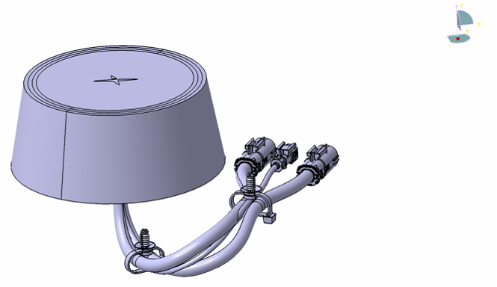

- 2x GNSS antennas (Representative image only, not exact design)
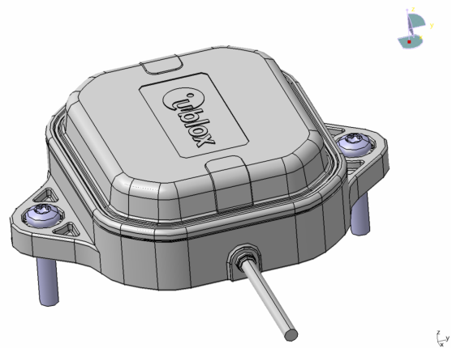
- 1x Siren-detection microphone (Representative image only, not exact design)
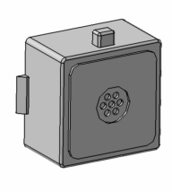

Reasons for development
TR information INF 54523319-3 v2
The COTS components are part of a key system that will provide self-driving capabilities to trucks, when combined with an autonomy-enable truck platform.

Usage and position in vehicle
TR information INF 54523319-4 v2
The antennas are located on the back of the cab. The microphone is integrated into the overhead panel.

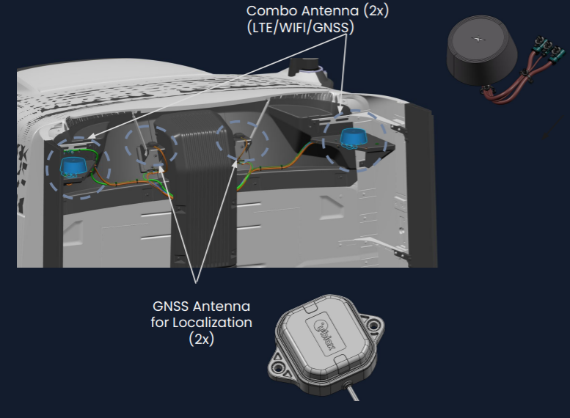

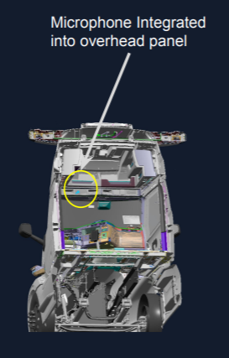

Owing to the specific Operational Design Domain (ODD) and use-cases for this generation of product, certain parameters and standard Volvo requirements may have been adjusted to account for this – including levels of expected vibration, shock, and operational temperature. It is understood that any alteration to the intended ODD or use-cases for the product shall drive a review of all requirements in this document, to confirm applicability to the new ODD or use-cases.

For the purposes of this Technical Requirements document, the ODD and use-case are understood to be:
(For discussion during RTS (Review of Technical Specifications) review)

Parameter | Specific | In Scope (Autonomous) | In Scope (all other vehicle operations)
Drivable Surface Type | Asphalt, Concrete | True | True
 | Brick, Cobblestone, Sett | False | True
 | Dir, Grass, Gravel | False | True
 | Tar&chip pavement | False | True
 | Railroad Tracks | False | True
Road Surface Object | Barrier_Curb | True | True
 | Botts_Dotts | False | True
 | Mountable_Curb | False | True
 | Speed_Bump | False | True
 | Raised_Pavement_Marker | True | True
 | Rumble_Strip | True | True
 | Manhole_Cover | True | True
Environmental | Ambient Temperature | -10/+44C operating | -40/+60C tolerate, survive
 | Ambient Relative Humidity | 10% ~ 90%
Use-case | Hub-to-Hub; improved surface streets and US Interstate system,

Reference: Volvo Trucks MVP Operational Design Domain Specification / Aurora doc 500-001581-01.

Variants
TR information INF 54523319-5 v2
The COTS components provided by Aurora will not have any variants.

Geometrical limitations or Interfaces
HWC requirement REQ 54523319-1 v2
No changes to the geometry, mounting provisions, or interfaces to any of the of the COTS components shall be made without coordination between Volvo and Aurora.

Interfaces – Design review
Verification method VM 54523319-1 v2
The fulfilment of the requirements is verified by a review of the component design with the concerned stakeholders.

Supplier Drawings
TR information INF 54523319-6 v2
Supplier drawings are important for conveying information between Aurora and Volvo and will be used for documentation of the Aurora components within the Volvo systems. The information in the drawings (both 2D and 3D) will be used for securing that the components are properly integrated – including in terms of geometry, physical properties, and process.

General 2D Drawing Requirements
HWC requirement REQ 54523319-2 v2
Aurora shall supply a manufacturer datasheet / specification sheet for each of the COTS parts which are the subject of this TR, indicating (at a minimum):
- All installation interfaces (interfaces between Aurora components and the vehicle platform) shall be fully documented either on the drawing, or on a referenced document (e.g., Aurora Interface Control Document, ICD)
- Materials and surface treatment shall be stated
- Weight (in kg) with tolerance shall be stated
- Administrative information: Supplier name, supplier document number (with revision), change log.

Verification method VM 54523319-2 v2
The fulfilment of the requirements shall be verified by a Drawing Review with the concerned stakeholders.

Pass criteria
Documented/stated compliance with requirements.

Criticality
HWC requirement REQ 54523319-3 v2
The COTS components which are the subject of this TR shall be analyzed with respect to criticality, according to Volvo STD 105-0007.
Any characteristics which are considered to be of criticality CC (Critical Characteristics) or SC (Significant Characteristics) according to Volvo STD 105-0007 shall be disclosed to Volvo. These CC/SC declarations must be associated with the product documentation when stored in the Volvo systems.

Verification method VM 54523319-3 v2
The fulfilment of the requirements shall be verified by a Design Review with the concerned stakeholders.

Pass criteria
Documented/stated compliance with requirements.

Functions
TR information INF 54523319-7 v2
This TR is not intending to define or describe any of the functions which the COTS components will perform.
This document is intended to describe the conditions (and tests to ensure the COTS components will survive those conditions), when operating as a critical element of an L4 Autonomous Transport Solution.

General test conditions
TR information INF 54523319-8 v2

If Aurora (or a chosen test house) chooses to perform any of the tests in this TR, then the following General Test Conditions shall apply to all tests:

Conditioning and general test conditions
According to STD 400-0001 Standard atmospheres for conditioning and testing.
The test samples shall be conditioned for 24 h before testing is performed.
Standard atmosphere class 1.
In between the heat treatment, ageing and climate-cycling stages, the part shall be conditioned in accordance with the section “Conditioning”.

Applicability
The requirements apply to the complete component, unless otherwise stated in relevant sections in this document.
Test samples
Testing shall be performed on complete components, unless otherwise stated. When these are not used, special test pieces must be made. All tests are applied on standalone Aurora components without any Volvo-supplied covers.
Complete-vehicle verification and component requirements
Component testing is a preparatory step in the complete vehicle or system verification.
The component shall fulfill component pass criteria, even when installed and tested in complete-vehicle or system-level tests.
If the component fails the complete-vehicle or system verification, the component design will need to be improved and the requirements in the component verification will need to be updated.

No component is allowed to fail during testing. A failure is defined as an event or occurrence outside the specification. Components must not be replaced during testing / the test sequence.
Testing shall be performed on production-grade material manufactured in a production-grade process. Any deviation shall be approved by Volvo VAS. The run rate for each process step shall be at least the run rate agreed. However, the entire process flow does not have to be in place. That is, the final production layout can be completed at a later stage. The only deviation from this is when consecutive process steps need to be carried out in sequence with the correct lead times (e.g. the process of coating and curing the coating must be done in a production-grade manner).
If production is performed in several cavities, each cavity shall be represented in the test population. Each variant of the product shall be represented by the number of samples given in the test overview, unless otherwise discussed with and accepted by Volvo.

Test conditions for electrical and electronic equipment

All testing shall be performed with the connectors and harness installed, unless otherwise stated in this TR. This includes mating the connectors and harness up to at least the first clamping point. For components with a metallic housing, the casing shall be connected to ground in same manner as in the truck. The component shall be installed the same way (fixing points, flange screws, etc.) and with the same angle as in the truck, based on the information provided by Volvo. The test objects shall be powered and connected to the load circuit during testing, in accordance with the operating mode definition, unless otherwise stated in the test specification.
The pass criteria description often has a reference to the Functional Status Classification (FSC).

Operating mode codes
Definition of codes for operating modes – see ISO STD 16750-1, chapter 5
Code | Definition
1 | No voltage is applied to the component.
1.1 | Not connected to wiring harness.
1.2 | Connected to wiring harness simulating vehicle installation.
2 | The component is electrically operated with test voltage, UB, as in a vehicle with generator off and with all electrical connections made.
2.1 | System/component functions are not activated.
2.2 | Systems/components with electric operation and control in typical operating mode.
3 | The DUT is electrically operated with test voltage, UA as in a vehicle with generator running and with all electrical connections made.
3.1 | System/component functions are not activated.
3.2 | Systems/components with electric operation and control in typical operating mode.

Functional status class (FSC)
Definition of the FSC classes – see ISO STD 16750-1, chapter 6
Code | Definition
FSC A | All functions of the component perform as designed (to specification), both during and after exposure to normal operating conditions or a disturbance.
FSC B | All functions of the component perform as designed during exposure; however, one or more functions may go beyond the specified tolerance. All functions automatically return to within normal limits after exposure is removed. Memory functions shall remain FSC A. The component shall not output any false actuation signals, erroneous serial data messages, false fault codes, or other erroneous Input/output (I/O) commands or states when the environmental loads are outside of the range defined for FSC A. For FSC B, all deviations (test case by test case) from FSC A must be agreed between the supplier and Volvo before C-release.  If applicable, add a list of functions that must be maintained during tests where FSC B is used.
FSC C | A function of the component does not perform as designed during exposure but automatically returns to normal operation after exposure is removed. The component shall not output any false actuation signals, erroneous serial data messages, false fault codes, or other erroneous I/O commands or states when the environmental loads are outside of the range defined for FSC A.
FSC D | A function of the component does not perform as designed during exposure and does not return to normal operation until exposure is removed and the component is reset by a simple operator action. The component shall not output any false actuation signals, erroneous serial data messages, false fault codes, or other erroneous I/O commands or states when the environmental loads are outside of the range defined for FSC A
FSC E | One or more functions of the component/system do not perform as designed during and after exposure, and cannot be returned to normal operation without repairing or replacing the component.  For Volvo components, this is not allowed except for short-circuits s to non-short-circuit-protected signal returns or Vcc-supplied sensors (Vcc=5V or lower) with short to battery test voltage levels above 16V. No thermal event is allowed for FSC E.

Evidence of test results
TR information INF 54523319-9 v2
For the Commercial-Off-The-Shelf (COTS) components which Aurora will be providing, verification of the requirements within this section can be satisfied by one of two ways:
- Aurora (or outsourced test house) conduct the TR-listed test (or an equivalent test, to be agreed between Volvo and Aurora) for each of the COTS components, and provide the requested proof of compliance, or
- Aurora provides evidence that each of the COTS components has been tested and/or certified by the manufacturer to pass the TR-listed tests (or an equivalent test, to be agreed between Volvo and Aurora).
(If this is the chosen path, it is Aurora’s responsibility to verify any manufacturer claims of compliance, since Aurora has chosen that supplier)

During the Review of Technical Specifications (RTS) – Aurora shall indicate their intended path for each COTS component, for each required test.

Verification overview

Test sequence
TR information INF 54523319-10 v2
TR tests that shall be performed in a specific sequence are documented below. The tests that are crossed-out are not required for the component. The following test sequences shall be discussed with stakeholders during RTS (Review of Technical Specifications) and TRA (Test Requirements Analysis).

Note: The tests which are clarified in the text of the TR needs to be done in the sequence specified in the figure. If there are any differences between this TR and the corresponding RTS and TRA, the RTS and TRA take precedence.

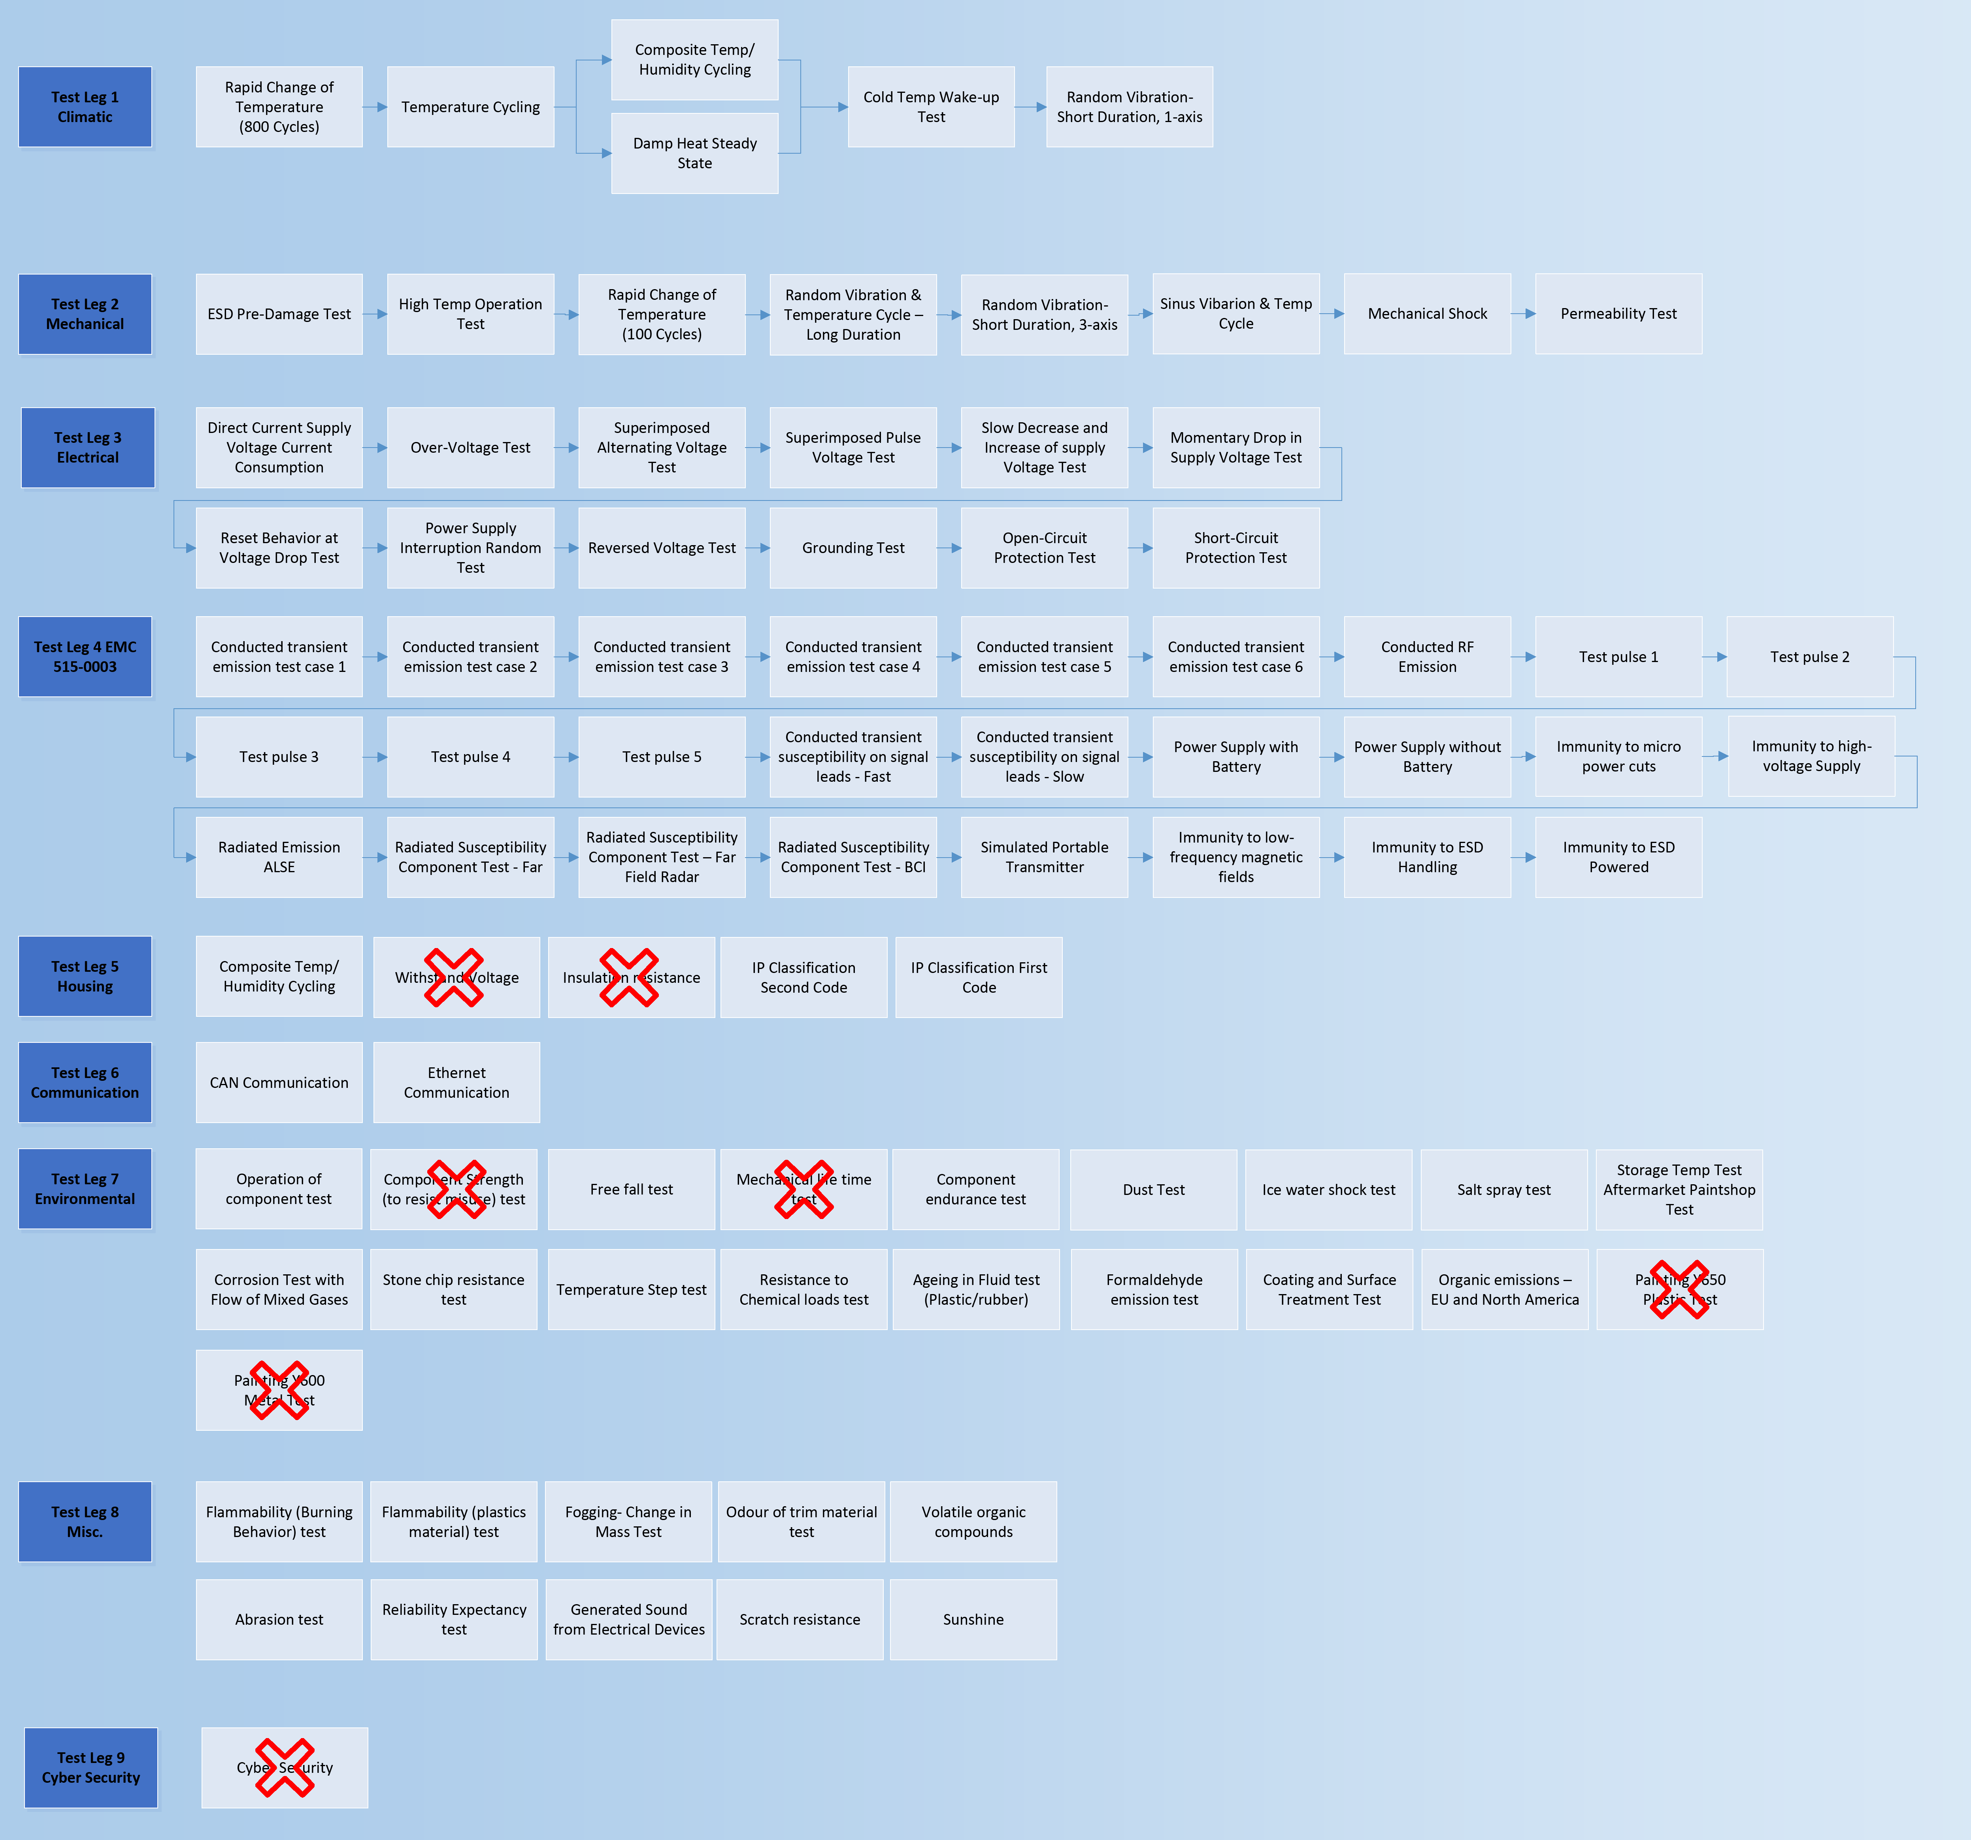

Test report content
TR information INF 54523319-11 v2
Test report content requirement.

1. First page is for those who doesn’t need to have the details but the result or don't need to read the whole report at this time, thus it needs to include what part is tested, what tests have been done, who did the tests and the result. For this reason, the first page shall at least include:
- Part and project name
- Supplier name
- Test lab
- Volvo Part no including version (maturity level)
- Tests performed
- Summary with conclusion.

2. For each separate test, there has to be enough facts for the reader to draw their own conclusions and, if desired: recreate the test in another lab. For this reason every test chapter (if several) shall at least include:
- Detailed test description including all applicable parameters, requirements, test sequence or test leg and how to perform the test. Including pictures of the setup. If the setup is too complex for pictures then an electric schematic is desirable.
- Description of test equipment including ID and calibration data.
- References to TR and/or STD and chapters.Initial measurements (Functional test) result, graphs, lists of
- measurements. Pictures
- Graphs, lists from measurements during the actual test. Both form DUT:s and equipment. Pictures
- Measurements between tests if the report is from a test sequence.
- Final measurements (Functional tests) result, graphs, lists of measurements. Pictures
- Results from opening and inspection. Pictures
- The suppliers detailed analysis of the result of the test

Test preparations

Initial and final status of component
HWC requirement REQ 54523319-4 v2
ASIL Value: Not Applicable

Each component shall be tested to perform its intended function as described by the manufacturer of the component, before and after testing.

All samples shall be visually inspected externally and opened for internal inspection after the test sequences have been completed.

- No defects which might affect the application, component or, if applicable, impression of the component quality is allowed.
- No unpleasant smell, mould or formation of fungus is allowed during or after the test.
- No cracks, corrosion, discolouration, spots, scratches, warping, fogging, fretting or other visible flaws or material degradations, or water intrusion onto/into PCB surfaces or voltage supplied structures are allowed.
- No rattling or noise is allowed.
- Labels on the component shall be attached to the component prior to C-sample testing. They shall be legible, have good adhesion and shall not smear after performed testing.

All samples shall be documented (e.g. by pictures and video clips) and a visual inspection report shall be part of the full set of test result reports provided to Volvo after test completion.

After inspection and test report creation, three (3) units shall be sent to Volvo (upon request). Two from climatic endurance, of which one has been subjected to damp-heat testing, one to high-humidity cyclic testing and one to the mechanical endurance test sequence.

Initial function test, normal climate
Verification method VM 54523319-4 v2
Perform the test with the stated parameters at room temperature.

Pass criteria
FSC A

Initial function test, cold climate
Verification method VM 54523319-5 v2
Perform the test with the stated parameters at T min.

Pass criteria
FSC A

Initial function test, hot climate
Verification method VM 54523319-6 v2
Perform the test with the stated parameters at T max.

Pass criteria
FSC A

Final function test, normal climate
Verification method VM 54523319-7 v2
Perform the test with the stated parameters at room temperature.

Pass criteria
FSC A

Final function test, cold climate
Verification method VM 54523319-8 v2
Perform the test with the stated parameters at Tmin.

Pass criteria
FSC A

Final function test, hot climate
Verification method VM 54523319-9 v2
Perform the test with the stated parameters at Tmax.

Pass criteria
FSC A

Post-test analysis
Verification method VM 54523319-10 v2
All components shall be tested to ensure they are operating as designed, following all tests. Any components that fail to perform as designed, shall be sent to the component manufacturer for analysis and failure report.

Pass criteria
A summary of each component’s condition shall be documented and reported to Volvo in the test reports.

Monitoring
HWC requirement REQ 54523319-5 v2
ASIL Value: Not Applicable
The output shall be continuously monitored during all tests and recorded for at least 100 cycles/20 seconds before and after any occurrences outside the specification, unless otherwise stated.
During testing in operating mode 2 or 3, enough parameters shall be monitored to ensure that the applicable FSC is fulfilled. Parameters and signals to be monitored shall be reviewed and agreed with Volvo.

Monitoring – Design review
Verification method VM 54523319-11 v2
The stated parameters to monitor shall be agreed before any testing starts.

Pass criteria
The list of parameters shall be confirmed in the test description.

Quality and Uptime
TR information INF 54523319-12 v2
Refer to ‎1.9.1 for evidence of test results.

Reliability/Durability
TR information INF 54523319-13 v2
The minimum expected lifetime of the COTS components provided by Aurora is expressed in years and km.

During the expected lifetime of COTS components provided by Aurora, the component shall perform the intended functions under the stated conditions without failure and resist ageing.

Reliability expectancy
HWC requirement REQ 54523319-6 v2
ASIL Value: Safety Related No ASIL
The COTS components shall demonstrate a minimum reliability of 90% with a confidence level of 90% for a period of 20000 system operating hours when operated in conditions relevant to the class 8 truck market for autonomous vehicles within North America.

Reliability expectancy - Design review
Verification method VM 54523319-12 v2
Volvo and supplier shall review the design review for reliability expectancy.

Pass criteria
Minimum reliability value with a confidence level according to requirement demonstrated by calculation.

Reliability expectancy – Test
Verification method VM 54523319-13 v2
Required reliability shall be demonstrated by testing sufficient samples until failure on highest critical failure modes/mechanisms identified in D/S FMEA. Alternatively a ‘success-test’ may be proposed to demonstrate required reliability and confidence level using existing test legs presented in the TR. Design of such tests, acceleration factors and sample size shall be agreed with Volvo. Time/cycles to failure in terms of normal usage shall be provided to Volvo for Reliability evaluation.

Pass criteria
Minimum reliability value with a confidence level according to requirement demonstrated by calculation.

Vibration
HWC requirement REQ 54523319-7 v2
ASIL Value: Safety Related No ASIL

During the lifetime of the vehicle, the component shall in its assembled position endure all vibration levels generated by the truck and the operating environment.

NOTE: The following Random and Sinus Vibration tables are only for preliminary design information, and were derived using simulation data. These values are only for design guidance and are subject to change in the future once data acquisition occurs on a SVAT-modified test object. The final test values might be higher or lower than indicated here.

Random vibration & temperature cycling – Long duration - Test
Verification method VM 54523319-14 v2
Perform the test according to ISO 16750-3 with all parameters according to the standard but replace the duration and acceleration levels with the following values.
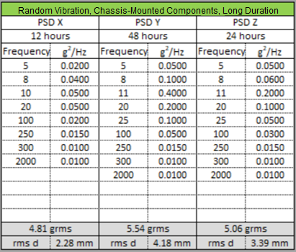

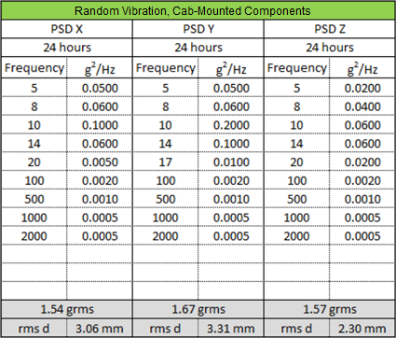

Random vibration test shall be carried out with all connectors in place (connector integrity is part of the test), including a representative wire harness and fixations. The fastening and positioning of the test objects shall be equivalent to that in the actual vehicle.
Note: The test shall be performed with simultaneous vibration and temperature cycling (according to ISO 16750-4 5.3.1, with the exception below).
Operating mode 3.2 during ramping from Tmin to Tmax according to the figure below.
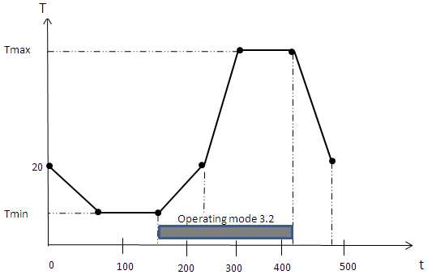
Operating mode 1.2 where no operation is required.
Pass criteria
FSC A and no cracks or breakage is allowed.

Random vibration - Short duration, 1-axis – Test
Verification method VM 54523319-15 v2
Perform the test according to ISO 16750-3 with all parameters according to the standard but replace the duration and acceleration levels with the following values.


Expose the component to random vibrations in the worst-case direction (Determined by the supplier) at room temperature and operating mode 3.2 for one hour.
Pass criteria
FSC A and no cracks or breakage is allowed.

Random vibration – Short duration, 3-axis – Test
Verification method VM 54523319-15 v2
Perform the test according to ISO 16750-3 with all parameters according to the standard but replace the duration and acceleration levels with the following values.
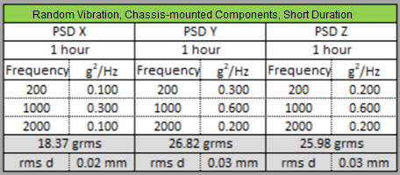
Expose the component to random vibrations for 1 hour per axis at room temperature and operating mode 3.2.
Pass criteria
FSC A and no cracks or breakage is allowed.

Sinus vibration & temperature cycling – Test
Verification method VM 54523319-16 v2
Perform the test according to ISO 16750-3 with all parameters according to the standard but replace the duration and acceleration levels with the following values.

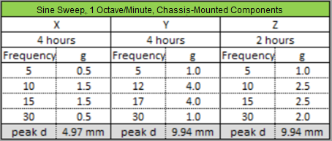

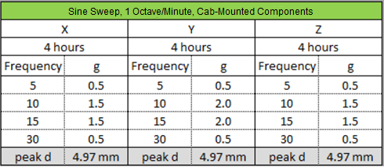

Sinus vibration testing shall be carried out with all connectors in place (connector integrity is part of the test), including a representative wire harness and fixations.
The fastening and positioning of the test objects shall be equivalent to that in the actual vehicle.
Note: The test shall be performed with simultaneous vibration and temperature cycling (according to ISO 16750-4 5.3.1, with the exception below).
Operating mode 3.2 ramping from Tmin to Tmax according to figure in Verification method VM 54523319-14 v2 Random vibration & temperature cycling – Test.
Operating mode 1.2 where no operation is required.

Pass criteria
FSC A and no cracks or breakage is allowed.

Mechanical shock – Test
Verification method VM 54523319-17 v2
- Chassis-mounted components: Test according to ISO 16750-3 test 4.2.2.2.
- Cab-mounted components: Test using a modified ISO 19453 specification with the following parameters: 20g, 6mSec, half-sine; ± direction on each of 3 axes; 100 repetition per direction.
Mechanical shock testing shall be carried out with all connectors in place.
(Connector integrity is part of the test) including a representative wire harness and fixations.
The fastening and positioning of the test objects shall be equivalent to that in the actual vehicle.
Pass criteria
FSC A and no cracks or breakage is allowed.

Multi-axial rig / shake – Test
Verification method VM 54523319-18 v2
The component should be installed on the multi-axial test rig (shake test …) in the same way as in/on the vehicle.
The load in/on the component shall be adapted to be as similar to actual customer usage as possible.
The rig will be subjected to road- and engine-related vibration that corresponds with Volvo test tracks.

Pass criteria
The component shall not move permanently out of its position during the test.
No defects in the shape or function of the component are allowed after the test has been performed.

AET – Test
Verification method VM 54523319-19 v2
The components should be mounted on a test vehicle and subjected to the Accelerated Endurance Test (AET) at a Volvo test track.
If applicable, the component shall be loaded with weight that is similar to actual customer usage.

Pass criteria
No defects in the shape or function of the component are allowed after the test has been performed.
No cracks that lead to loss of structural integrity are allowed on the component after the test has been performed.
The component shall not squeak or rattle during the test.

Dust intrusion
HWC requirement REQ 54523319-8 v2
ASIL Value: Safety Related No ASIL
The components and electrical connectors that make up the COTS components shall be resistant to intrusion of dust.
NOTE: The requirement is for the stand-alone Aurora component without Volvo-supplied covers.

Degrees of protection (1st IP code) – Test
Verification method VM 54523319-20 v2
- Exterior-Mounted Components: Test according to ISO 20653:2013, IP first code number= IP6Kx.
- Interior-Mounted Components: N/A

Pass criteria
According to stated IP code.

Dust – Test
Verification method VM 54523319-21 v2
Perform the test according to ISO 16750-4, chapter 5.10 Dust test.
Use the recommended parameters in ISO 16750-4.
Test dust shall consist of the below mixture (as suggested in the standard):
– 50 % by weight limestone (with clay and sand), i.e. “unbaked Portland cement”, and
– 50 % fly ash with the following grain size distribution (in accordance with IEC 60068-2-68):
– 33 % by weight ≤ 32 μm;
– 67 % by weight > 32 μm, but ≤ 250 μm.
Number of cycles 20
The functions shall be activated 10 times per cycle
1/3 of the components shall be brushed off after the test before functional testing
1/3 of the components shall be cleaned with compressed air before functional testing
1/3 of the components shall be tested without cleaning before functional testing.

Pass criteria
No intrusion of dust that can degrade the functional, electrical, mechanical or cooling properties is allowed.

Moisture intrusion
HWC requirement REQ 54523319-9 v2
ASIL Value: Safety Related No ASIL
The components and electrical connectors that make up the COTS components shall be resistant to intrusion of moisture.
NOTE: The requirement is for the stand-alone Aurora component without Volvo-supplied covers.

Permeability and operational – Test
Verification method VM 54523319-22 v2
Perform a sealed temperature/humidity cyclic test in accordance with Volvo STD 515-0004.
Tmedium = +5 ºC
Exposure time: “Stabilization Time” + 10 min (measured in “Stabilization time test” (VM 54523319-30 v1), defined in the “Climate cycling” requirement in the TR).
Use either a plastic container or plastic bags for the test. If plastic bags are used:
- Seal the bags with a bag sealer (e.g. Quick-Seal Cut Model 300C)
- Ensure that all connectors and their wiring harness are connected to the component.
- Prevent moisture intrusion if no connector is attached to the other end of the wiring harness.
- Ensure that both ends of the wiring harness are sealed.
- The specification above requires an opening and inspection of the component after performed test.
- Do not open and inspect the component after performed permeability test.
Operating mode 1.2

Operational test
After testing in accordance with the standard specified above, perform an operational test.
Preparation:
Open the plastic container/plastic bags after (within 8 h) the testing specified above and place them immediately in a new plastic container/plastic bag and seal it.
Ensure that the components can be operated, i.e. that the wiring harness can be connected to power and/or controls.
Test duration: 10 days
Climate chamber temperature: 5 ºC
Operating mode 3.2, continuous monitoring
Functional test, normal climate to be performed within 2 h after performed combined permeability & operational test, test duration 24 h.

Pass criteria
FSC A during the operational test. No intrusion of moisture/water is allowed.

Water intrusion
HWC requirement REQ 54523319-10 v2
ASIL Value: Safety Related No ASIL
The components and electrical connectors that make up the COTS components shall be resistant to intrusion of moisture.
NOTE: The requirement is for the stand-alone Aurora component without Volvo-supplied covers.

Ice water shock, splash – Test
Verification method VM 54523319-23 v2
Test according to ISO 16750-4 §5.4

Pass criteria
FSC A and no intrusion of water into the component.

Ice water shock, Submersion – Test
Verification method VM 54523319-24 v2
Test according to ISO 16750-4 §5.4

Pass criteria
FSC A and no intrusion of water into the component.

Degree of protection (2nd IP code) – Test
Verification method VM 54523319-25 v2
- Exterior-Mounted Components: Test according to ISO 20653, IP second code number= IPxK9K.
- Interior-Mounted Components: N/A

Pass criteria
FSC A and no intrusion of water into the component.

Salt spray – Test
Verification method VM 54523319-26 v2
Perform ISO 16750-4 5.5.2 leakage and functional test.
Exception from ISO 16750
Operating mode 3.2 (during test duration)

Pass criteria
FSC A and no intrusion of water into the component. No corrosion is allowed inside the component.

Atmospheric environment lifetime
TR information INF 54523319-14 v2
Since this component is powered by the ADM (Aurora Driving Module) system and not the vehicle power bus, the Usmin, Usmax, Usnom are defined by Aurora for the tests. The value for these voltages shall be noted in the test report.

Operating temperature
HWC requirement REQ 54523319-11 v2
If no specific temperature profile is communicated by Volvo, the component shall be fully functional and meet all requirements in the range of –Tmin < T < Tmax for all possible temperature profiles during the component and vehicle life cycle
Tmin -40°C
Tmax 85 ºC

Cold temperature wake-up – Test
Verification method VM 54523319-27 v2
Perform ISO 16750-4 § 5.1.1.1 Low temperature test, Storage test (off) for 24 h, but with operating mode 1.2. After 24 h still at Tmin, go to operating mode 3.2 with Usmin supply voltage and monitor electrical functionality including the on transition. Cycle the power ON (100 s) / OFF (20 s) for 1 h and monitor that each ON period starts and functions correctly until power off.

Pass criteria
FSC A while powered for each ON cycle.

High temperature, operation – Test
Verification method VM 54523319-28 v2
Long-term heat resistance for electrical components
Test duration: 500h
Test according to ISO 16750-4 5.1.2 High temperature test, Operation test
Operating mode 3.2, continuous monitoring
The test operating voltage shall be Usnom for 80 %,
Usmin for 10 % and Usmax for 10 % of the test time.

Pass criteria
FSC A. Geometry gaps and flushes according to specification.

Sunshine
TR information INF 54523319-15 v2
Sunlight is part of the electromagnetic radiation generated by the Sun, in particular infrared, visible, and ultraviolet light. Sunshine is a combination of bright light and radiant heat.

HWC requirement REQ 54523319-12 v2
The component shall be resistant to degradation due to sunlight and sunshine, combined with relevant atmospheric conditions such as high temperatures, humidity and wetting.

Light exposure (exterior) – Test
TR information INF 54523319-16 v2
Accelerated ageing for exterior plastics substrates and painted surfaces, by artificial light, in combination with raised temperature and intermittent wetting

Verification method VM 54523319-29 v2
Accelerated ageing test should apply to any plastic parts which are exposed to light and controlled by the supplier.
According to STD 1027,337 Light exposure – Accelerated ageing of exterior material – Test Method
Temperature according to STD
Exposure time: 1500 h for surfaces which represent true exposure in the vertical position and 2000 h for surfaces which represent true exposure in the horizontal position.

Pass criteria
The system performance should remain unaffected. In the event of any performance degradation, the system should have the capability to detect it. Additionally, Volvo shall be informed of the test results.

Climate cycling
HWC requirement REQ 54523319-13 v2
The component shall be able to withstand and maintain functionality in varying temperatures, e.g. when the components are used in changing ambient temperatures. (Tmax–Tmin).

Stabilization time – Test
Verification method VM 54523319-30 v2
Before starting any climate cycling test, the stabilization time (ts) of the component shall be measured.
Stabilization occurs when the temperature difference (ΔT) between the test specimen and the test medium is within Tmax – 3°C or Tmin +3 °C. This measurement shall be carried out by applying a thermocoupler to the part of the component with highest thermal mass.
Take into account that the stabilization time will also depend on the chamber and the number of components being tested.

Pass criteria
Stabilization time for the largest thermal mass in the component.

Rapid change of temperature (thermal shock) – Test
Verification method VM 54523319-31 v2
Number of cycles, Rapid change of temperature I (see Test overview, leg 1) 800.
Number of cycles, Rapid change of temperature II (see Test overview, leg 2) 100.
Use test method according to IEC 60068-2-14 Test Na Rapid change of temperature with prescribed time of transfer.
Operating mode: 1.2 connected to wire harness but not powered.
Dwell time: see Stabilization Time.
Adjust Tmax to compensate for internal heating. Example: If a component is specified for 85 °C and internal heating is 10 °C, then Tmax=95 °C.
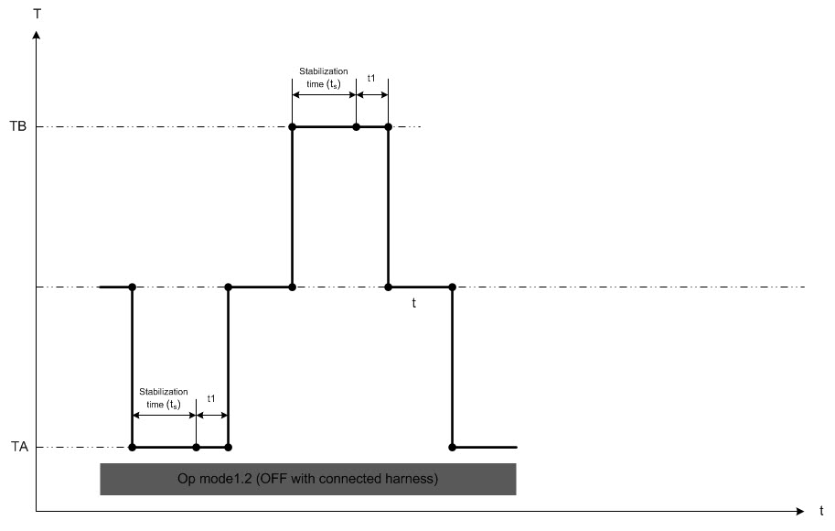

TA=Low temperature in °C
TB=High temperature in °C
T, temperature in °C
t, time
t1=10min, Duration of exposure after temperature stabilization (See chapter Verification method VM 54523319-30 v2)

Pass criteria
FSC A

Temperature cycling – Test
Verification method VM 54523319-32 v2
Use test method IEC 60068-2-14 Test Nb. Change of temperature with specified rate of change
Operating modes in accordance with TR /Test conditions chapter (function definition only for operating mode 3.2).
3.1 if sleep mode is applicable / 1.2 if sleep mode is not applicable, during the negative thermal transition and the low-temperature phase.
3.1 if sleep mode is applicable / 1.2 if sleep mode is not applicable and 3.2, respectively, during the positive thermal transition and the high-temperature phase. When Tmin + 3 C is reached, begin cycling ON (Operating mode 3.2) 100 s and OFF (Operating mode 3.1/1.2) 20s until the next negative thermal transition begins.
Operating mode 3.2
Monitor continuously. In operating mode 3.2, the test voltage shall be Usnom for 80 %, Usmin for 10 %, and Usmax for 10 % of the completed cycles.
Use the following parameters:
Temperature range: Tmin to Tmax (denoted TA and TB in IEC 60068-2-14)
Transition time: 2–15 °C/min,
Duration of exposure: see Stabilization Time (Verification method VM 54523319-30 v2)
Number of cycles: 100 (minimum 100 cycles)

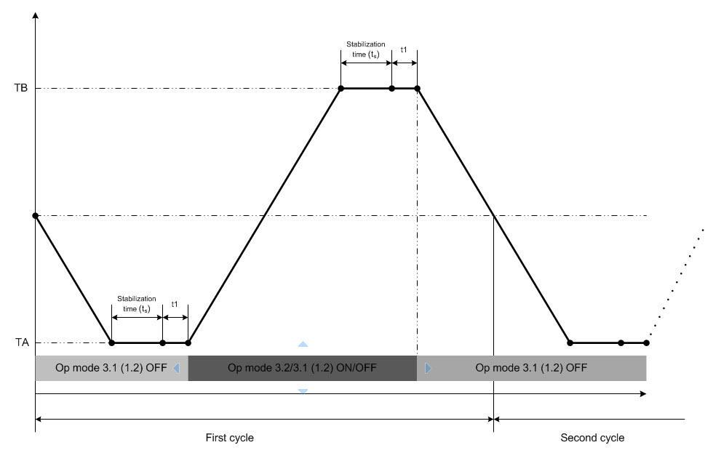
TA=Low temperature in °C
TB=High temperature in °C
T, temperature in °C
t, time
t1=10min, Duration of exposure after temperature stabilization (See chapter Verification method VM 54523319-30 v2)

Pass criteria
FSC A

Temperature step – Test
Verification method VM 54523319-33 v2
Test according to ISO 16750-4 § 5.2 Temperature steps test
Operating mode 3.2 at each temperature step
Exception: Follow ISO 16750-4 § 5.2, but increase the temperature steps as follows:
After reaching T max, decrease the temperature in steps according to the standard, to +20 °C.

Pass criteria
FSC A

Process oven temperature
HWC requirement REQ 54523319-14 v2
For any components expected to remain mounted in place on the vehicle during any aftermarket paint booth / paint curing processes, then the component shall be able to withstand the painting process and oven temperatures (Tmin 100 °C) while not operating.
For any component(s) unable to withstand the painting process oven requirement above, Aurora shall notify Volvo so that operations can be instructed to remove the component(s) prior to the painting / curing process.

For components requesting exemption, the component supplier shall acknowledge during the RTS and also state during the PHR (Part Handling Review) process.

Storage temp aftermarket paintshop – Test
Verification method VM 54523319-34 v2
Place the component in a hot air oven at 100 °Celsius for 2 hours.
For components requesting exemption, the component supplier shall acknowledge during the RTS.

Pass criteria
No cracks or deformations and no degradation of functionality.

Moisture
HWC requirement REQ 54523319-15 v2
The components and electrical connectors that make up the COTS components shall be resistant to moisture, both in form and function, from very dry up to 95 +/–5 % relative humidity.
No unpleasant smell, mould or formation of fungus is allowed during normal handling, transport, storage or mounting.

NOTE: The requirement is for the stand-alone Aurora component without Volvo-supplied covers.

Composite temperature/Humidity cycling – Test
Verification method VM 54523319-35 v2
Perform the test according to IEC 60068-2-38 Z/AD, except for the requirements on functional cycling and monitoring. Instead, apply the requirements below.

Operating mode: Cycle between ON (Operating mode 3.2) for 1 h and Sleep mode (op. mode 2.1 or OFF if the component has no Sleep mode) for 1 h, starting with the first hour OFF.
Between hour 17 and 21, the unit shall be OFF/in Sleep mode. Supply voltage: Usnom.
During the ON mode, continuous monitoring is required. During the Sleep/OFF mode, continuous parasitic current is monitored and recorded over the 10-day test period to detect any malfunctions during the test.

Pass criteria
FSC A. No increase in parasitic current greater than 50 % is allowed.

Damp heat, steady state – Test
Verification method VM 54523319-36 v2
Perform the test according to IEC 60068-2-78, Damp heat, steady state, but with the following parameters:
Temperature: +65 ± 3 ºC
Relative Humidity: 93 ± 3 % R.H.
Duration: 10 days.

Operating mode: Cycle between ON (op. mode 3.2) for 1 h and Sleep mode (op. mode 2.1 or OFF if the component has no Sleep mode) for 1 h. To avoid local drying of the component, the heating should be minimized and other ON/OFF cycling might be necessary. Supply voltage: Usnom. During the ON mode, continuous monitoring is required. During the Sleep/OFF mode, continuous parasitic current is monitored and recorded over the 10-day test period to detect any malfunctions during the test.

Pass criteria
FSC A. No increase in parasitic current greater than 50 % is allowed. No signs of electro-migration or dendritic growth at final inspection.

Air pollution
HWC requirement REQ 54523319-16 v2
The component’s functionality shall not be affected by the surrounding air, both clean and polluted.
The operation, functionality and surface of the component shall not be adversely affected by air pollution when used in the vehicle.

Corrosion test with flow of mixed gases – Test
Verification method VM 54523319-37 v2
Expose the component to a mixture of three gases with concentrations according to table below in a MFG (Mixed Flowing Gas) climatic chamber

Gas | Concentration [ppb]
H₂S | 2000
NO₂ | 200
SO₂ | 200

Temperature: +4 0°C ± 3 °C
Test duration: 504 h
Relative humidity: 75 ± 3 %
Operating modes: 2.1 (OFF) and 3.2 (ON),
Test cycle: 1 hour ON, 1 hour OFF
Check the functionality of the test objects after one and two weeks (operating mode 3.2).

Pass criteria
FSC A
Note: The device may show signs of corrosion.
The following items shall be monitored and shall not fail or cause failures in the test:
– Copper creep shall not have short circuited any electrical nets
– All chip resistors shall be functional with correct resistance values
– All LEDs, including any with silicone-optical protections, shall function normally. (A bare-eye inspection is sufficient.)

Quality impression
TR information INF 54523319-17 v2
Quality Impression (QI) is the perception of the product quality with engine off; at 0 km. Quality impression is an important aspect and this component shall support the overall quality impression as specified by volvo.

Surface finish
TR information INF 54523319-18 v2
Not applicable.

QI Solidity
TR information INF 54523319-19 v2
Solidity is the perceived quality of attachment, material rigidity, sound and deterioration
HWC requirement REQ 54523319-17 v2
General
• All materials must be fixated in a sufficient and appropriate number of points to fulfill flex and attachment requirements
• There shall be no perceivable freeplay when knocking/tapping on assembled parts
• No parts or surfaces shall be perceived as being weak or too flexible in any direction.
• All moveable/adjustable parts shall deliver a solid perception and should only be moveable in the, for the function, intended direction (e.g. lids, doors, drawers, handles)
• There shall be no perceived noise such as creaking, squeaking or rattling when operating part(s) including pushing/pulling and knocking on part

QI Solidity – Evaluation
Verification method VM 54523319-38 v2
Evaluation to occur on B- and C-builds using representative parts from Aurora. Volvo GTT to provide input as well as design review.

Pass criteria
The fulfilment of the requirements is verified by a review of the component design with the concerned stakeholders.

Corrosion
HWC requirement REQ 54523319-18 v2
The component shall not adversely affect the quality impression of the vehicle or impede functionality.

Corrosion test on complete vehicle – Test
Verification method VM 54523319-39 v2
Test according to SAE J2721 complete vehicle corrosion test.

Pass criteria
To be defined

Scratch resistance
HWC requirement REQ 54523319-19 v2
The component surface shall be resistant to scratching, both during manufacturing and over the vehicle’s expected lifetime.

Scratch resistance by Erichsen pen – Test
TR information INF 54523319-20 v2
The purpose of this verification method is to assess the appearance of materials with small scratches that occur during manufacturing and over the vehicle’s expected lifetime.
Verification method VM 54523319-40 v2
According to STD 423-0030 Scratch resistance, Erichsen pen - Organic materials
Method A, needle 2, Spring 2 (ERICHSEN PEN)
Force load: 3 N minimum

Pass criteria
The system performance should remain unaffected. In the event of any performance degradation, the system should have the capability to detect it. Additionally, Volvo shall be informed of the test results.

Scratch resistance (abrasive paper) – Test
TR information INF 54523319-21 v2
The purpose is to assess the appearance of materials with hard scratches that occur during manufacturing and over the vehicle’s expected lifetime.

Verification method VM 54523319-41 v2
Test according to STD 423-0040 Scratch resistance using abrasive paper - Organic materials.

Pass criteria
According to STD 423-0040 Scratch resistance using abrasive paper - Organic materials
The grey-scale assessment shall be ≥ 4 according to ISO 105-A03 Scale – staining (alt. Volvo STD 1026,8202 Grey scale – staining).

Chemicals
HWC requirement REQ 54523319-20 v2
The operation, function and surface of the component shall not be adversely effected by accidental liquid splash or spray, etc. of any type of chemical agents, detergents or liquids used in the vehicle over the expected lifetime.
The surface shall not be stained due to contact with other adjacent materials such as varnishes, plastics, rubber, etc.

Resistance to chemical loads – Test
Verification method VM 54523319-42 v2
According to Table 1 in ISO 16750-5 with mounting location code D.

Operating mode: 1.1.
Application method: Table 2 in ISO 16750-5.

Pass criteria
The minimum functional status shall be class A in accordance with ISO 16750-1.
The surfaces and material shall not be degraded.
Any marking and labelling shall remain visible and legible.

Ageing in fluids (plastic/rubber) – Test
Verification method VM 54523319-43 v2
Test according to ISO 1817 Rubber, vulcanized – Determination of the effect of liquids.
Temperature: 85 °C

Pass criteria
No cracks or dimensions outside of tolerances are allowed.

Material and composite materials properties
HWC requirement REQ 54523319-21 v2
The (composite/plastic/metal) material properties shall contribute to fulfilment of all component requirements, over the component’s expected lifetime.
The plastic material properties shall fulfil the requirements in STD 411-0001 Plastics.
The requirement is considered for Aurora-supplied component without the Volvo-supplied covers.

Material properties – Documentation
Verification method VM 54523319-44 v2
Documentation (e.g. supplier’s Material Data Sheet) shall certify that the material’s properties are in accordance with the specified requirements.

Pass Criteria
Documented/stated compliance with the requirements.

Maintainability
TR information INF 54523319-22 v2
Maintainability is the ease of performing routine maintenance such as Daily maintenance ( i.e. checking the oil level), Preventive maintenance (i.e changing the oil and filter), Corrective maintenance (repairs), and Diagnosis.
If Aurora components have any effect on volvo components, they need to abide by the following maintainablity reqs and should coordinate with any other project workgroups focusing on this area, including required periodic maintenance, maintenance intervals, etc.

Design for maintainability
HWC requirement REQ 54523319-22 v2
Maintenance operations
- The use of glue to assemble parts shall be avoided for preventive/corrective maintenance of parts.
- Replacement of components shall not require a recalibration. If a recalibration cannot be avoided, it shall as far as possible be automatic and not require any special tools (e.g. scales) or a diagnostic application (such as TechTool). A software download shall never require a manual recalibration.
- Uptime-critical components (that cause breakdown or unplanned maintenance) shall be easy to access (removal of bolts, connectors, joints, etc.) for diagnostic operations (e.g. manual measurements).
- Removal of unrelated components shall not be required for preventive and corrective maintenance.
- The need to open panels, hatches or tilt the cab in order to perform daily maintenance shall be avoided.
- The fault tracing time shall be considered in component design in complex installations.
Quick connectors
- If no Standard parts are used for connection, quick connectors shall be provided for all pneumatic and fuel routings and easy-disconnect connectors for wiring harnesses.
Tools
- The component design shall be optimized to limit the number of standard workshop tools needed to perform maintenance operations, independent of installation or application.
- The use of special tools shall not be required.
- No standard tools shall be required to disconnect quick connectors.
Fluid draining/filling/checks
- The filling and draining rate of fluids shall be at least 10 litres/min for proper upkeep and operation.
- It shall be possible to check fluid levels without dismantling the ingoing parts of the component (e.g. removal of filler plug for oil-level check in drive axle is acceptable).
Lifting aid on the component
- Components heavier than 5 kg shall be provided with a lifting aid, such as a hook, lifting eye, keyhole.
Replacement durability
- Replacement of components shall not require destructive removal of related components (e.g. a removal of the fork from the shaft in a differential lock shall not require drilling out the lock pin).
- Components with snap-fits, for example clips, shall have a replacement durability of at least 25 cycles.

Design for maintainability – Design review
Verification method VM 54523319-45 v2
Compliance with design for maintainability requirements is verified through a review of the concept solution documentation in an early development phase.

Pass criteria
Maintenance operation time, convenience evaluation and service contract cost
Documented/stated compliance with the specified requirements.

Safety
TR information INF 54523319-23 v2
The areas considered for the safety tests are collision safety, operator safety and fire protection. Aurora shall be responsible for supporting Volvo in all of the required simulations per each unique installation, and shall provide manufacturer datasheets / evidence of compliance to automotive safety standards.

Driver (operating) environment
TR information INF 54523319-24 v2
Refer to ‎1.9.1 for evidence of test results.
Aurora shall work with Volvo to ensure that none of the COTS components (nor installations) contribute to the following:

- Noise
  - Squeak and rattle
  - Wind noise
  - Noise generated by electrical devices

Environment – Materials and environmental impact
TR information INF 54523319-25 v2
Refer to ‎1.9.1 for evidence of test results.
The Volvo Group’s goal is to be ranked as a leader in terms of Environmental Care among the world’s top producers of transport-related products, equipment and systems. The Volvo Group’s Environmental Care programmes shall be characterized by a holistic view, continuous improvement, technical development and resource efficiency. These means shall give the Volvo Group a competitive advantage and contribute to sustainable development.
Focus areas are Choice of material, Resource efficiency, Reduction of emissions, Waste management.

Each new component shall strive for an environmental improvement in comparison with its predecessor.

Design for recycling
HWC requirement REQ 54523319-23 v2
General
- All materials and components shall be suitable for recycling in the end-of-life phase, and the risk of exposure to toxic materials shall be minimized and declared.
- Special attention shall be paid to component accessibility, ease of extraction at end-of-life, dismantling, and the existence of a recycling process.
- Dismantling information shall be provided.
Attachment components (Nuts, screws, clips, etc.) shall be:
- standardized and the number of attachment components shall be reduced to a minimum.
- “rapid assembly systems”, such as clips, if possible.
Reservoirs and fluid/gas systems (for fluids and gases) shall:
- be designed with a single low point. (At end-of-life, fluids will be extracted through suction or by gravity.)
- be accessible (windscreen washer, brake and cooling fluids, etc.).
- have an emptying plug, i.e. fuel, windscreen washer fluid, brake fluid, cooling fluid, oils (engine, gearbox, drive axle, power steering, shock absorbers, etc.), air conditioner fluid, etc.
Metal inserts – If metal inserts are used in plastic components, limit their size.
Disassembly – All components shall be easy to disassemble/dismantle, including:
- Components that need to be treated in separate processes (e.g. oil filters, batteries, etc.)
- No-n-organic, non-metallic materials, e.g. windows, especially glued windows
- Batteries. If the component is equipped with batteries, the recommendations in the battery directive 2006/66/EC—2008/103/EC Directive on batteries and accumulators, shall be followed.
- If pyrotechnic functions (e.g. pre-tensioners and airbags) cannot be dismantled, design a simple, efficient neutralization system.

Design for recycling – Design review
Verification method VM 54523319-46 v2
The fulfilment of the requirements shall be verified by a review of the component design with the concerned stakeholders.
The design for recycling and minimization of environmental impact shall be approved by Volvo in a design review before B-release.

Pass criteria
Documented/stated compliance with requirements.

Material selection
HWC requirement REQ 54523319-24 v2

- Materials shall be selected to minimize the environmental impact regarding hazardous substances, recyclability, waste management, and material emissions.
- Take into consideration how can the component and material can be refurbished, remanufactured to make the useful life of the component and material longer and in the end recycled.
Solvent-borne surface treatment shall not be used in the cab interior. This requirement does not apply to PCB coating and treatment of electrical cables.
Polymer materials
- Whenever possible, use a single family of polymer materials, for instance PP family or ABS family.
- All components in polymer materials shall be evaluated and considered for design using recycled material, when the required properties and characteristics are achieved. For all non-visible components, it is recommended to use recycled polymers. Components made from recycled material shall be correctly labelled.
- To minimize the production waste of plastic, recycled plastic materials can be used as long as the properties of the component are not compromised, and the parts are correctly labelled.
- PVC shall only be used without hazardous additives.

Material selection – Design review
Verification method VM 54523319-47 v2
The fulfilment of the requirements is verified by a review of the component design with the concerned stakeholders.
The material selection shall be approved by Volvo in a design review before C-release / freeze of tool design.
To support the review use Volvo Group Eco-design tools.

Pass criteria
Documented/stated compliance with requirements.

Substances that shall not be present in product
HWC requirement REQ 54523319-25 v2
The component shall fulfil the requirements in STD 100-0005 “Volvo´s red list” – Chemical substances which shall be declared and substances that must not be present in Volvo Group products placed on the market
- If applicable, components located in the cab interior shall be free from Brominated Flame Retardants (BFR).
- If a chemical substance needs to be labelled, applicable labelling requirements shall be followed.
- If a biocide is used, the active substance shall be approved for the product type according to the EU Biocide directive. If a part/product is treated with a biocide, it shall be labelled accordingly. This requirement also applies when no biocide is left in the product.
- If transport protection for example corrosion protection oils are used or the component contain chemical products secure that STD 100-0002 and STD 100-0003 are fulfilled.

Substances that shall not be present in product – Reporting
TR information INF 54523319-26 v2
Supplier Substances reporting is mandatory in Technical P-release (frozen reporting) and reporting is requested from C-release. An accepted MDS is the condition for PPAP acceptance. The detailed process for PPAP acceptance will be communicated by the Purchaser on the Volvo Group Supplier Portal.
When point 4. above is applicable the chemical content of the chemical product needs to be reported.

Verification method VM 54523319-48 v2
Reporting according to STD 100-0006 MDS (Material Data Sheet) reporting of substances and material composition to IMDS (International Material DatabaSe) by the supplier.
Reporting by the supplier of all process chemicals, within the Volvo Group, into Flecs (Volvo France), MoTiV, or other, equivalent system used within the Volvo Group.

Pass criteria
Documented/stated compliance with requirements.

Emissions and odours
TR information INF 54523319-27 v2
Applies to interior-mounted components only.

Driving performance

Transport effectiveness

Component weight
TR information INF 54523319-28 v2
The truck GCW (Gross Combination Weight), GVV (Gross Vehicle Weight), Axle Weight and dimensions are regulated by law through a Certificate of Conformity.
The weight also has a strong influence on the features Load Capacity, Fuel Consumption, and Environmental Impact.
Legislation and features put pressure on developers to optimize the weight of produced trucks in order to increase the payload for the truck and make it help customers to increase their income.

HWC requirement REQ 54523319-26 v2
The weight shall be reduced as much as possible, and kept under control.
The weight should be documented and any time it changes, volvo shall be notified.

Component weight – Documentation
Verification method VM 54523319-49 v2
Verification by documentation of estimated weight or weighed component, in Volvo’s system (KOLA) at registration of a new part number.
Updates of accuracy at the (A, B, C, P) releases, for example from CAD calculations or weighed prototype parts.
At PPAP, an average of 5 weighed components shall be documented in Volvo’s systems.

Pass criteria
Documented/stated compliance with requirements.

Vehicle regulation and Regulative conditions

Vehicle regulations and certification
HWC requirement REQ 54523319-27 v2
The component shall comply with all relevant regulations, including applicable installation regulations (that will affect the component) on the markets where it will be sold, according to the list below

Requirement Area | Market | Regulation / Certification reference (including series supplement and year when applicable) / Standards connected to legal requirement | Is a certificate or test report required | Required type approval marking (on component or drawing)

Aurora shall
- notify Volvo if any of the COTS components are subject to any Federal, State, or local regulations or certifications
- provide documentation to Volvo prior to C-release that the COTS components meet required regulations or certifications

Vehicle regulations and Certification (xxx) – Design review
Verification method VM 54523319-50 v2
To be confirmed in documentation.

Pass criteria
Documented/stated compliance with requirements.

Electrical & Electronics
TR information INF 54523319-29 v2
Refer to ‎1.9.1 for evidence of test results.

E&E mechanical properties

Silicone-free
HWC requirement REQ 54523319-28 v2
The use of silicone as a cleaning agent, release agent, lubricant, paste, adhesive, inside dampers or any other non-cross-linked or uncured silicone where risk of leakage of volatile silicone to surroundings occur is not permitted.

In general, cross-linked silicone such as silicone rubber or cured silicone rubber shall not emit any low-molecular agents that can be harmful or have any functional impact on electrical appliances or in paint shop.

Any silicone materials used in the design of units with electrical functionality, including mechanical switches, micro switches and relays controlling inductive loads, shall be reviewed with Volvo. This includes silicone oil, silicone grease, and silicone rubber parts. The evaporation of silicone molecules on surfaces that can see electrical arcing will cause open-circuit failures over time.

Silicone- free – Design review
Verification method VM 54523319-51 v2
Use of any material containing silicone shall be reviewed, discussed and documented.

Pass criteria
Documented/stated compliance with the specified requirements.

Sulphur-free rubber
HWC requirement REQ 54523319-29 v2
No sulphur-cured rubber material is allowed inside of the Component.
Peroxide-cured material or silicone-rubber materials shall be used.
This requirement also applies to rubber sealings in electrolytic capacitors.

Sulphur-free rubber – Design review
Verification method VM 54523319-52 v2
The sulphur content shall be discussed and approved before B-release.

Pass criteria
Documented/stated compliance with the specified requirements.

Lead-free
HWC requirement REQ 54523319-30 v2
Electrical and Electronic Assemblies shall have a lead-free design.
The definition of a lead-free requirement is a quantity limit of 0,1 % by mass (1000 ppm) in homogeneous material for Lead (Pb).
Examples of electrical and electronic assembly materials:
• Solder used to connect electrical and/or electronic parts to a circuit board (substrate) or a lead frame (without a substrate)
• Coating on connector terminals and "pre-soldering" of wires and components prior to soldering, crimping etc. (See Annex II for pressfit / compliant pin exemption)
• Bare PCB surface finish for soldering preservation
• Protective coatings on the circuit board (Conformal coat materials)
• Shrink hoses for components on the circuit board.

Lead-free – Design review
Verification method VM 54523319-53 v2
The lead-free content shall be identified during RTS.

Pass criteria
Documented/stated compliance with requirements.

Connectors
HWC requirement REQ 54523319-31 v2
Connectors used shall be from Volvo connector palette.

If the component is equipped with more than one connector of a certain type, all of the connectors shall be individually and mechanically coded to achieve "poka yoke". If possible, colour coding in combination with mechanical coding is also preferred.

The connectors that need to be in TR are the ones that Volvo has control over.

Connector – Design review
Verification method VM 54523319-54 v2
The fulfilment of the requirements is verified by a review of the component design with the concerned stakeholders.
The requirement applies to the connectors that Volvo has control over.

Electrical wiring
HWC requirement REQ 54523319-32 v2
Applicable for components with wiring pigtails.
Aurora shall inform Volvo about the type, length and resistance of wires and cables.
The pigtail should be designed so that it can tolerate the weight of the component if it is held by the wires.

The following standards needs to be considered for the design.

Applicable for all wires
STD 525-0001 Wires - Dimensions, test methods and requirements
STD 525-0004 Cables - Dimensions, test methods and requirements

Pin description
HWC requirement REQ 54523319-33 v2
Required signals for different connectors are listed below. Pin assignment shall be done by supplier based on PCB design and layout. The PCB track lengths of differential signal pair between SoC outputs and connector terminals shall be the same.

The Pins that need to be in TR are the ones that Volvo has control over.

Connector number | Pin number | Pin name | Function name
1 |  | TBD | TBD
1 |  | TBD | TBD

Connector number | Pin number | Pin name | Function name
2 |  | TBD | TBD
2 |  | TBD | TBD

Pin description – Documentation
Verification method VM 54523319-55 v2
Shall be verified in the component documentation.

Pass criteria
Shall be confirmed by all stakeholders.

Printed Circuit Board (PCB) assembly
HWC requirement REQ 54523319-34 v2
The choice of PCB type used material qualifications and workmanship shall be according to the pass criteria of IPC J-STD-001 class 3 for safety-related components.
The types of fluxes used for the soldering processes shall be according to IPC J-STD-004.
Allowed flux classification according to J-STD-004 ROL0, ROL1, REL0 and REL1.
Use No Clean type. Do not clean the boards unless otherwise agreed on.
Do not use water-soluble fluxes
Acceptable substrate materials FR4-types, CEM3 (low-population boards), Polyimide, Ceramic.

Any shaping and cutting of the PCBs shall not damage the PCB, initiate cracks in the soldering or damage the components.

Bare PCB surface finish
Acceptable bareboard surface finishes on organic substrates (FR4, CEM3 etc.) are:
ENIG, HASL, ImSn, OSP.
Silver material surfaces ImAg SHALL not be used.

PCB assembly – Design review
Verification method VM 54523319-56 v2
The PCB properties shall be identified during RTS.

Pass criteria
To be confirmed in documentation and process description.

PCB Conformal Coating
HWC requirement REQ 54523319-35 v2
All PCBs shall be protected by conformal coating or corresponding method which provides electrical insulation and sufficient resistance to corrosion. The supplier shall present the choice of method and type of lacquer at the start of the design phase. The supplier shall also secure the coating’s feasibility in the layout design. If the PCB is not completely protected by lacquer, this shall be approved by Volvo.
The thickness of conformal coating shall be as follows as the type specified. If other than the following types of conformal coating being used, this shall be approved by Volvo.
Coat type | Short name | Curing remarks | Coating thickness, in mm, in accordance with IPC J-STD-001
Acrylic | AR |  | 0,03–0,13
Epoxi | ER |  | 0,03–0,13
Silicone | SR |  | 0,05–0,21
Urethane | UR | Do not use oxygen curing coating | 0,03–0,13
Parylene | XY |  | 0,01–0,05

Solvent-free coatings shall be used for all materials. Do not use water as a solvent.
Coating Processes: Dip, Spray, Selective Spray, Vapor Deposit
Coating Material Selection Matrix
 | AR | ER | SR | UR | XY
Operating temp  –40 – 85 °C | OK | OK | OK | OK | OK
Operating temp  –40 > +85 °C | NOK | OK | OK | NOK | OK
IP Code ≤5k3 | OK | OK | NOK | OK | OK
IP Code ≥5k4 | OK | OK | OK | OK | OK
Note 1: For the operating temperature range above +85 °C, AR-and UR-conformal coating materials shall not be used due to the mechanical forces created during thermal cycling for parts where the coating applies external forces on solder joints (Minimelf, QFP, BGA, PLCC, etc.)
Note 2: Silicone-conformal coatings in combination with sulphur vapors from rubber or air pollution are very aggressive on silver-content parts like chip resistors and LED lead frames. Open-circuit faults can be created over time.

PCB conformal coating –Design review
Verification method VM 54523319-57 v2
To be discussed and agreed before B-release

Pass criteria
To be confirmed in documentation.

E&E Production requirements

End Of Line functional – Test
HWC requirement REQ 54523319-36 v2
Each delivery unit must pass the functional test after assembly. Volvo and the supplier shall jointly specify the measurements that will be performed. Also, the dimensions and requirements shall be checked and agreed with Volvo. The test environment shall be supplied by the supplier. Possible test software shall be developed by the supplier. The documentation of all production line tests shall be available for Volvo (both intermediate tests between each production step and end of line tests).

EoL – Design review
Verification method VM 54523319-58 v2
EoL (End of Line) test shall be agreed before B-release.

Pass criteria
Documented/stated compliance with requirements.

In-Circuit Test
HWC requirement REQ 54523319-37 v2
Each delivery unit shall pass an ICT (In-Circuit Test) or a combination of ICT and alternative verification methods. Full verification coverage is expected.
The verification process shall include power-up of the micro controller(s), connectors and all other components. The verification procedures used by the supplier shall be reviewed and agreed with the Volvo Group.

ICT – Design review
Verification method VM 54523319-59 v2
Verification (ICT or combination) test shall be agreed before C-release.

Pass criteria
Documented/stated compliance with requirements.
To be confirmed in documentation and process description where a coverage matrix shall be presented and approved.

Electrical Properties Low Voltage
TR information INF 54523319-30 v2
- If the COTS component is connected to / powered only by the ADM, then it shall be tested as part of the ADM System, and these sections may not apply (to be discussed on a case-by-case basis).
- If the COTS components is powered directly from one of the vehicle platform power busses, then the COTS compoent shall be tested per the following tests, or else evidence shall be provided that it complies with the folowing tests (from the component manufacturer)

Voltage rating
HWC requirement REQ 54523319-38 v2

The 12V-powered components associated with the ADM shall work in the electrical supply voltage range of electrical code “B” from ISO 16750-2 Chapter 4.2.2.

The 24V-powered components of the ADM shall work in the electrical supply voltage range of electrical code letter “H” from ISO 16750-2 Chapter 4.2.2.

Electrical Code Letter | U_{N} = [V] | Minimum supply voltage  U_{smin} for FSC A  [V] | Maximum supply voltage  U_{smax} for FSC A  [V]
E | 24 | 10 | 32
F | 24 | 16 | 32
G | 24 | 22 | 32
H | 24 | 18 | 32

Parameter | Symbol | Condition | Unit | U_{N} = 12 V |  |  | Comments
 |  |  |  | min | nom | max
Supply Voltage | U_{s_range} | Maximum supply voltage range | V | –14 |  | +24 | No Damage within given time limits, FSC C
 | U_{s_normal} | Normal supply voltage range, steady state | V | 0 | 14 | U_{s max} | FSC C –> FSC A  For the life of the component
 | U_{s_operating} | Operating voltage range | V | U_{s min} | 14 | U_{s max} | Normal operation FSC A
 | U_{A} | Test voltage | V | _{Us min} | 14 | U_{s max} | Generator operating. FSC A. Op mode 3.1 and 3.2
 | U_{B} | Test voltage | V | _{Us min} | 12 | 12 | Generator not operating. FSC A. Op mode 2.1 and 2.2
 |  | Reduced functionality | V | 6.0 | 6.5 | U_{s min} | 6 V required for functions required during Engine Crank. 6,5 V is not a cost driver and can be used as nominal
 |  | Power down/up hysteresis | V |  | 0,5

Parameter | Symbol | Condition | Unit | U_{N} = 24 V |  |  | Comments
 |  |  |  | min | nom | max
Supply Voltage | U_{s_range} | Maximum supply voltage range | V | –28 |  | +48 | No Damage within given time limits, FSC C
 | U_{s_normal} | Normal supply voltage range, steady state | V | 0 | 28 | U_{s max} | FSC A, B and C.  For the life time of the component
 | U_{s_operating} | Operating voltage range | V | U_{s min} | 28 | U_{s max} | Normal operation FSC A
 | U_{A} | Test voltage | V | _{Us min} | 28 | U_{s max} | Generator operating. FSC A. Op mode 3.1 and 3.2
 | U_{B} | Test voltage | V | _{Us min} | 24 | 24 | Generator not operating. FSC A. Op mode 2.1 and 2.2
 |  | Reduced functionality | V | 8 | 8 | U_{s min} | 8 V required for functions required during Engine Crank. 8 V is not a cost driver so can be used as nominal.
 |  | Power down/up hysteresis | V |  | 0,5

Parameter | Symbol | Condition | Unit | U_{N} = 3,3 V or 5,0 V |  |  | Comments
 |  |  |  | min | nom | max
Supply Voltage | U_{s_range} | Maximum supply voltage range | V | 0 |  | U_{s max} | No Damage, FSC C
 | U_{s_normal} | Normal supply voltage range, steady state | V | 0 | 3.3 or 5.0 | U_{s max} | FSC C –> FSC A  For the life of the component
 | U_{s_operating} | Operating voltage range | V | U_{s min} | 3.3 or 5.0 | U_{s max} | Normal operation FSC A
 | U_{A} | Test voltage | V | U_{s min} | 3.3 or 5.0 | U_{s max} | Generator operating. FSC A. Op mode 3.1 and 3.2
 | U_{B} | Test voltage | V | U_{s min} | 3.3 or 5.0 | U_{s max} | Generator not operating. FSC A. Op mode 2.1 and 2.2

Slow decrease and increase of supply voltage – Test
TR information INF 54523319-31 v2
The purpose of the test is to catch circuits that aren't fully reset unless the voltage is less than 0,4–0,6 V.
Verification method VM 54523319-60 v2
Test according to ISO 16750-2 Slow decrease and increase of supply voltage.

Pass criteria
FSC A is required inside the supply voltage range and FSC C is required outside the supply voltage range.

Momentary drop in supply voltage – Test
Verification method VM 54523319-61 v2
Test according to ISO 16750-2 Momentary drop in supply voltage.

Pass criteria
FSC A. If a reset is allowed, FSC C is OK.

Over-voltage – Test
Verification method VM 54523319-62 v2
Systems with 12 V nominal voltage
Test with supply voltage 18 V. Test duration: 1 h at Tmax – 20 °C in a hot air oven.
Test with supply voltage 24 V. Test duration: 5 min at room temperature.

Systems with 24 V nominal voltage
Test with supply voltage 36 V. Test duration: 1 h at Tmax – 20 °C in a hot air oven.
Test with supply voltage 48 V. Test duration: 2 minutes at room temperature.

Pass criteria
FSC C

Power supply interruption – Random test
TR information INF 54523319-32 v2
This test simulates a glitchy circuit in the voltage supply. In Case A, the glitchy circuit is on the supply side, while in Case B it is on the grounding side. This type of situation can occur when someone is connecting or disconnecting the battery, creating contact bounces.

Verification method VM 54523319-63 v2
Operational mode 3.2 with continuous monitoring
Test method
1. Place the component in a climate chamber.
2. Place the test equipment and test loads in a room-temperature environment (see GTINF18 General test conditions).
3. Connect the supply lines to the component according to Test Setup A with switch S2 closed.
4. Stabilize the component at Tmin. Apply Usnom (14 or 28 V) to the test voltage source Us.
5. Monitor the component performance and record the Ui voltage node at failure.
6. Touch the file surface U1 with the probe P1 connected to the component. Open switch S2. Move probe P1 along the file surface U1 back and forth with a speed of approx. 0–1 cm/s. The mechanical force of the probe P1 against the surface U1 shall be adjusted so that a relay chatter due to frequent connections/disconnections is heard. Continue for 5 minutes or until a malfunction is indicated by the monitoring equipment, then close S2 to maintain the condition with the supply voltage applied.
7. Investigate any found issues such as hardware failures, code runaway due to reset and/or watchdog malfunction. Record any triggered permanent fault codes.

Repeat steps 3 to 7 with Test Setup B
Equipment: File, any fine-cut file for metalworking. Relay, standard plug-in ISO Mini relay TE V23134-A0052-X278(12V), V23134-A0056-X4333(24V) or equivalent. Use a 12 V or 24 V suppressed (Rpar=10*Rcoil) coil relay,depending on the component Usnom.

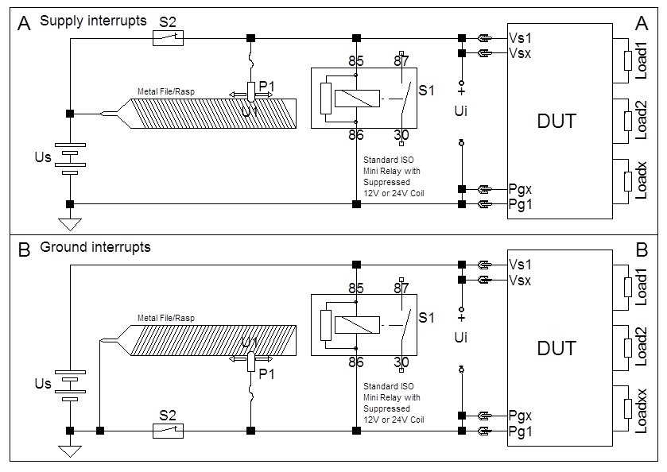
Test setups for power supply interruption, Random

Pass criteria
FSC A

Reset behaviour at voltage drop – Test
Verification method VM 54523319-64 v2
Perform the test according to ISO 16750-2 Reset behaviour at voltage drop.
Operating mode 3.2
Then repeat the same test with the following remarks and modifications:
The component shall be connected to all real or equivalent loads for inputs and real loads for outputs.
The component shall be connected to all voltage-supply/ground pins and be soaked for 2h at Tmin unpowered before the test.
Remaining at Tmin, decrease the test voltage in steps of 5 % for each pulse from 100 % to 0 % of Usmin.
Verify the FSC A performance after each and every pulse of the 20 voltage drops after returning to Usmin.
Be very observant on that the reset is not appearing by itself more than one time after each drop.
If the internal voltage supply does not reach its steady-state value within the 5-second drop time, or if the 10-second function test time at Usmin is too short, the 5-second voltage-drop time or the 10-second function-test time shall be increased to fulfil this requirement of FSC A analysis after each voltage drop.

Pass criteria
FSC A

Reversed voltage – Test
Verification method VM 54523319-65 v2
Test according to ISO 16750-2 Reversed voltage
– Case 1 and Case 2 for 12 V systems.
– Case 2 for 24 V systems.
Correct loads shall be connected during the test. It should be stated whether the outputs shall be designed to handle the full current in reverse.

Pass criteria
FSC A

Superimposed alternating voltage – Test
Verification method VM 54523319-66 v2
Test according to ISO 16750-2 § 4.4.
The superimposed alternating voltage test shall be performed with severity 2.

Pass criteria
FSC A

Superimposed pulse voltage – Test
TR information INF 54523319-33 v2
This test simulates variations in Us within specification. The variations are caused by other loads in the vehicle. These can be due to the start of an electric motor that reduces the Us through high current consumption (inrush current) or a voltage increase caused by the deactivation of a motor and other inductive loads. A load controlled by a PWM circuit can also disturb the Us.
The sudden voltage drop can be detected by the ECU as a zero-current consumption by the load (the charge in the internal capacitors of the load might drive the load for a very short moment). The possible error can be that the ”Open circuit DTC” is sent out incorrectly. Similarly, a sudden increase in voltage might lead to a very short current rush from the ECU to the load (to charge the internal capacitors of the load). The possible error can be that the ”Short circuit DTC” is sent out incorrectly..

Verification method VM 54523319-67 v2
Test Definitions
Uo = Us + Up
Us = (Usmin + 2V) to (Usmax – 2 V) DC Voltage
Up = Square wave, – 1.0 to +1.0 V 50% duty cycle (2 V p–p)
Up-sweep frequency = 1 Hz to 4 kHz
Frequency sweep = Logarithmic
Frequency sweep duration = 120 s for 1 Hz to 4 kHz to 1 Hz
Operational mode = 3.2

Test Method
1. Place the component in a climate chamber and connect to the Uo output.
2. Raise the temperature to Tmax and stabilize.
3. Set Us = Usmax – 2,0 V.
4. Perform five continuous frequency sweep cycles while monitoring for permanent or intermittent faults.
5. Decrease Us by 1,0 V for 12 V components and 2,0 V for 24 V components.
6. Repeat steps (4) and (5) including Us = Usmin + 2,0 V.
7. Repeat steps (3) to (6) at Tmin.

Pass criteria
FSC A

Power consumption
HWC requirement REQ 54523319-39 v2
For any COTS components powered by of the vehicle power busses, Aurora shall provide documentation to Volvo, describing:
- The minimum power consumption, and under which conditions that shall be achieved,
- All different operational scenarios / conditions which drive their different power modes / power states,
- Appropriate vehicle platform requirements related to their power needs

Direct current supply voltage and current consumption – Test
Verification method VM 54523319-68 v2
Set the supply voltage as specified in GTREQ51 to all relevant inputs of the component.
Measure the current consumption of the component at room temperature and Usmin Usnom Usmax at Tmax as well as Usmin Usnom Usmax at Tmin, and Usmin Usnom Usmax according to the voltage rating requirement for all implemented power states. Also, measure the inrush current when switching from power OFF to ON and from the power states Sleep and Standby to Operational (if power states are supported).
Operating mode: (Operational) 3.2
Implemented Power state: see Power consumption requirement
Operating mode: Sleep to Operational 3.1/3.2
Operating mode: Standby to Operational 2.1/3.2

Pass criteria
–FSC A (If Sleep mode and/or Standby mode are applicable)
–FSC A and FSC C (If Sleep mode and/or Standby mode are not applicable)

Grounding
HWC requirement REQ 54523319-40 v2
The component shall be able to withstand ground or supply voltage offsets.
If the casing of the Component is metallic, the power ground (pg) of the unit shall not be directly connected to the case with a low- DC-resistance connection.
Metallic sub-components shall not be electrically floating.
There shall be a capacitive coupling between the metallic casing and the Component power ground (C_case typically 100nF)
There shall be a high-ohm-value resistive path equal to 100 kOhm between the case and the power ground in the component.
The metallic casing itself shall have a direct connection to the vehicle chassis, cab or engine ground through metallic bolts or a wire connection.

Grounding – Test
TR information INF 54523319-34 v2
This test shall verify the component’s ability to function properly when subjected to ground or supply voltage offsets.
The tests are applicable to all inputs on the component without signal return lines (signal_rtn) or outputs with at least one external connection to the tested component supply or ground line to the connected load. This means all I/Os on the component where voltage offsets occur in the supply or ground line(s). Voltage offsets will occur between different components within a vehicle.
Operational mode 3.2 with continuous monitoring is required.

Verification method VM 54523319-69 v2
Test method for Ground offset
The ground offset shall be applied separately and simultaneously to each ground line of the I/O simulation device. The simulation device shall be constructed to meet the specified component loads. (Insert reference to components supplied or sufficient information for constructing equivalent loads for testing.)
1. Apply Usmin to the component.
2. Subject the applicable ground line of one representative I/O simulation device to a +1,5 V offset relative to the component ground.
3. Perform a function test operating mode 3.2 at Usmin and Usmax
4. Repeat step (2 and 3) for the next applicable I/O simulation device.
5. Repeat step (2 and 3) for all I/O simulation devices simultaneously.
6. Repeat steps (2) through (5) for a –1,5 V offset relative to the component ground.
7. Repeat steps (2) through (6) with Usmax instead of Usmin.

Test method for Supply offset
The supply voltage offset shall be applied separately and simultaneously to each supply line of the I/O simulation device. The simulation device shall be constructed according to the electrical interface documentation.
1. Apply Usmin to the component.
2. Subject the applicable supply line of one representative I/O simulation device to a –1,5 V offset relative to the component supply voltage (Uoffsx=+1,5 V).
3. Perform a function test operating mode 3.2 at Usmin and Usmax
4. Repeat step (2 and 3) for the next applicable I/O simulation device.
5. Repeat step (2 and 3) for all I/O simulation devices simultaneously.
6. Repeat steps (2) through (5) for a +1,5 V offset relative to the component supply voltage (Uoffsx = –1,5 V).
7. Repeat steps (2) through (6) with Usmax instead of Usmin.

Pass criteria
FSC A

Open-circuit protection
HWC requirement REQ 54523319-41 v2
All inputs and outputs (except battery supply and ground pins) shall be protected against open circuits.

Open-circuit protection – Test
Verification method VM 54523319-70 v2
Test according to ISO 16750-2 Single line interruption and/or Multiple line interruption.

Pass criteria
The requirement is FSC A for interruption of signal circuits, except for interrupted circuits, where FSC C applies.

Short-circuit protection
HWC requirement REQ 54523319-42 v2
All inputs and outputs of the component shall be protected against short-circuits to battery and ground over the entire voltage and temperature range. This requirement includes hard and soft shorts to both supply and ground.
The component shall be designed to withstand the current required to trigger the power supply fuse or, as a minimum, a TBD A MINI blade fuse with a wire length of 1000 mm and a cable area of TBD mm2.
A hard short is defined as 0 Ohm for inputs and outputs. A soft short is defined as Ishort =1,35*Imax and Ishort=6*Imax for outputs, supply and ground lines.
The current through the component during a short-circuit shall be limited to avoid component damage. Shorting of inputs for power-to-ground and ground-to-battery will stress the harness instead of the component. Load returns and signal references that are grounded within the component shall also be protected against shorts to battery. Common active methods to protect Load returns and Signal references are serially connected PTC-resistors with the ground connection or a permanently switched-on, low-side, smart-FET driver to ground (with thermal short-circuit protection as a minimum). In case of no active protection of the Signal_rtn and the use of a copper track for the Signal reference to the Power_gnd connection, this track shall be designed to be the weakest point and shall be located on the top or bottom PCB layer so that the trace will act as a fuse in the event of a short to battery.

Short-circuit protection – Test
Verification method VM 54523319-71 v2
Test according to ISO 16750-2 Short circuit protection, Signal circuits.
Test according to ISO 16750-2 Short circuit protection, Load circuits.
- Perform at min, nominal and max operating temperatures
- Use a representative wire length and cross-section (use 3 m as default length)
For electronic protection, apply for Loadx 110 % and 600 % of the maximum output-rated current.
For passive protection (fuse), apply for Loadx 135 % and 600 % of the maximum output-rated current with corresponding (maximum) time duration defined In ISO 8820.
Test cases and Operating modes
1 ⎯ Connected supply voltage and ground terminals
a. Outputs active => Operating mode 3.2
b. Outputs inactive => Operating mode 3.1 and 3.2
2 – Disconnected supply voltage terminals => Operating mode 1.2
3 – Disconnected ground terminals => Operating mode 1.2

Pass criteria
Test case 1
– Units with electronic protection. Requirement is FSC C for shorted circuits and FSC A for other circuits.
– Units with passive protection (fuse). Requirement is FSC D.
Test cases 2 and 3: FSC D

HW start up time
HWC requirement REQ 54523319-43 v2
The components internal electronics shall be fully functional after no longer than 50 ms after power up, ready to execute code.

HW start up time – Test
Verification method VM 54523319-72 v2
The component is to be started up with intended SW or a similar test SW.

Pass criteria
The startup time shall be less than 50ms

Electromagnetic Compatibility (EMC)
HWC requirement REQ 54523319-44 v2
The tests shall be performed in accordance with Volvo STD 515-0003.

Severity index (SI): TBD based on joint discussions
- IMU:
- LTE antenna:
- GNSS antenna:
- Beeper:

Whenever Volvo STD 515-0003 is in conflict with another standard or test specification, Volvo
STD 515-0003 contains the applicable requirement.

Applicable for devices (components) serving as power supply:

Volvo STD 515-0003 shall be fulfilled within the load range specified for the DUT.

Test should be performed at expected worst case load and nominal load.

Since the component is powered by the ADM, it should be tested as part of the ADM system.

NOTE: Disturbances shall be applied at the relevant wires at the vehicle to ADM connection (interface) with the COTS components connected to the ADM.

NOTE: The measurements for conducted transients and emissions shall be done at the vehicle to ADM connection (interface) with the COTS components connected to the ADM.

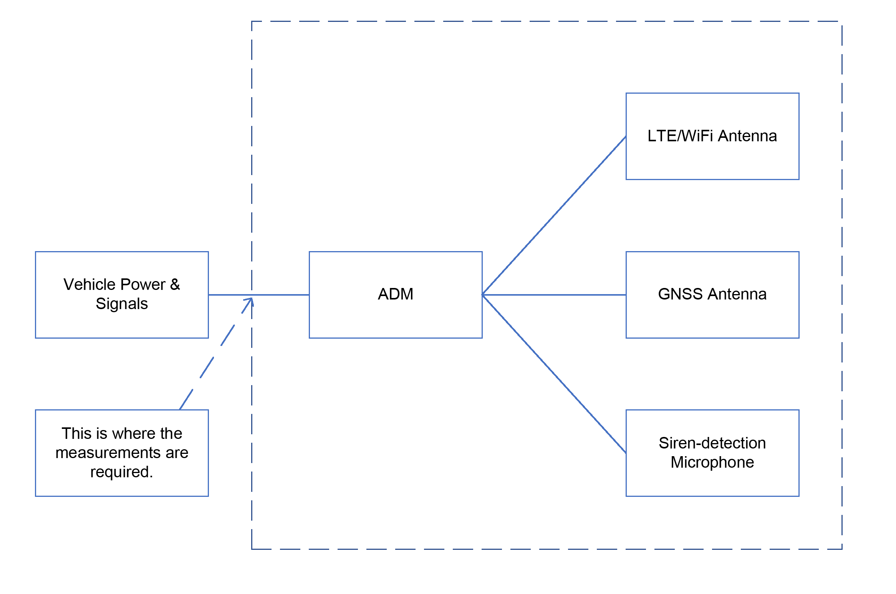

Conducted Transient emission
HWC requirement REQ 54523319-45 v2
From STD 515-0003 4.1

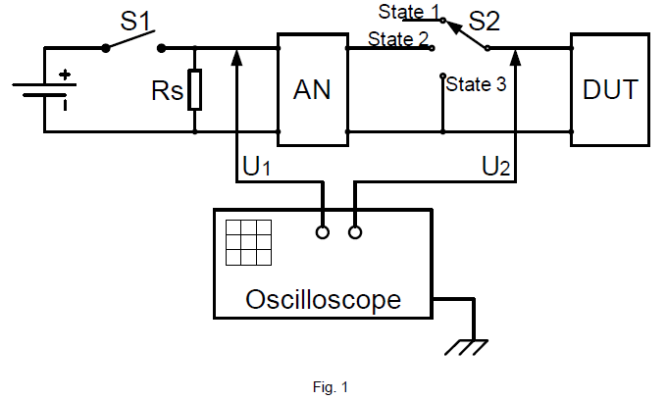

This procedure conforms to ISO 7637-2.

This test is intended to evaluate permanent interference, as well as switch-off and switch-on transients
sent from the DUT (Fig. 1). It is also intended to evaluate “braked/disconnected” electric motors (state 3).

Permanent interference shall be measured when switch S1 is closed and switch S2 is closed to state 2.

Transients are measured when opening or closing switch S1, and when switching S2 between its different states.

Exception: If a complete system is purchased from a supplier, the system might be regarded as a component,
and the conducted emission requirement shall apply to the system and not to the specific components.

Conducted transient emission Test case 1
Verification method VM 54523319-73 v2
The test set-up shall be in accordance with ISO 7637-2, section 4.3.

S1 state | S2 state | Test goal | Times to be repeated
Permanently | Permanently | Waveforms sent | 1
closed | closed to state 2 | by DUT

Pass criteria:
24V system | 12V system
U2*= -75V < U2 < +50V | -50V < U2 < +50V

(*U2 = Ua + Us, where Ua is the supply voltage and Us is the disturbance voltage or superimposed transient voltage)

U1 and U2 waveforms recordings shall be sent to Volvo for analysis.

Conducted transient emission Test case 2
Verification method VM 54523319-74 v2
The test set-up shall be in accordance with ISO 7637-2, section 4.3

S1 state | S2 state | Test goal | Times to be repeated
Permanently | Switching from | Waveforms sent | 10
closed | state 2 to state 1 | by DUT

Pass criteria:
24V system | 12V system
U2*= -75V < U2 < +50V | -50V < U2 < +50V

(*U2 = Ua + Us, where Ua is the supply voltage and Us is the disturbance voltage or superimposed transient voltage) U1 and U2 waveforms recordings shall be sent to Volvo for analysis.

Conducted transient emission Test case 3
Verification method VM 54523319-75 v2
The test set-up shall be in accordance with ISO 7637-2, section 4.3.

S1 state | S2 state | Test goal | Times to be repeated
Permanently | Switching from | Waveforms sent | 10
closed | state 1 to state 2 | by DUT

Pass criteria:
24V system | 12V system
U2*= -75V < U2 < +50V | -50V < U2 < +50V

(*U2 = Ua + Us, where Ua is the supply voltage and Us is the disturbance voltage or superimposed
transient voltage) U1 and U2 waveforms recordings shall be sent to Volvo for analysis.

Conducted transient emission Test case 4
Verification method VM 54523319-76 v2
The test set-up shall be in accordance with ISO 7637-2, section 4.3.

S1 state | S2 state | Test goal | Times to be repeated
Opening (from | Permanently | Waveforms sent | 10
ON to OFF) | closed to state 2 | by DUT, AN and Rs

Pass criteria:
24V system | 12V system
U2*= -75V < U2 < +50V | -50V < U2 < +50V

(*U2 = Ua + Us, where Ua is the supply voltage and Us is the disturbance voltage or superimposed
transient voltage) U1 and U2 waveforms recordings shall be sent to Volvo for analysis.

Conducted transient emission Test case 5
Verification method VM 54523319-77 v2
The test set-up shall be in accordance with ISO 7637-2, section 4.3

S1 state | S2 state | Test goal | Times to be repeated
Closing (from | Permanently | Waveforms sent | 10
OFF to ON) | closed to state 2 | by DUT, AN and Rs

Pass criteria:
24V system | 12V system
U2*= -75V < U2 < +50V | -50V < U2 < +50V

(*U2 = Ua + Us, where Ua is the supply voltage and Us is the disturbance voltage or superimposed
transient voltage) U1 and U2 waveforms recordings shall be sent to Volvo for analysis.

Conducted transient emission Test case 6

Verification method VM 54523319-78 v2
The test set-up shall be in accordance with ISO 7637-2, section 4.3.

S1 state | S2 state | Test goal | Times to be repeated
Permanently | Switching from | Waveforms sent | 10
closed | state 2 to state 3 | by DUT

Pass criteria:
24V system | 12V system
U2*= -75V < U2 < +50V | -50V < U2 < +50V

(*U2 = Ua + Us, where Ua is the supply voltage and Us is the disturbance voltage or superimposed
transient voltage) U1 and U2 waveforms recordings shall be sent to Volvo for analysis.

Conducted RF emission – Voltage method
HWC requirement REQ 54523319-46 v2

From STD 515-0003 4.2

Reference document
Components shall comply with the requirements defined in CISPR 25, Edition 05 or as agreed.

Field of application
This test is intended to evaluate the radio-frequency conducted disturbances generated by the DUT
and its power supply wiring.

Principal characteristics
- Frequency band [0,15–108 MHz]
- Peak detector and average detectors shall always be used.
- Peak and average detection are used for compliance with both average and peak limits.

Frequency bands outside of CISPR 25 bands are also included, not shaded in the table.

In case of overlap between bands, the lower limit shall apply.

Conducted RF emission
Verification method VM 54523319-79 v2

Reference levels
The device(component)/system shall comply with the requirements specified in Table 4 (similar to CISPR Class 5)

Table 4

Band |  | Frequency | Peak detector |  | Average detector
 |  | band (MHz)
 |  |  | Limit value dB | BW (kHz) | Limit value dB | BW (kHz)
 |  |  | (µV) |  | (µV)
LW | 1) | 0,15–0,30 | 70 | 9/10 | 50 | 9
 | 2) | 0,30–0,53 | 70 | 9/10 | 50 | 9/10
MW | 1) | 0,53–1,8 | 54 | 9/10 | 34 | 9/10
 | 2) | 1,8–5,9 | 54 | 9/10 | 34 | 9/10
SW | 1) | 5,9–6,2 | 53 | 9/10 | 33 | 9/10
 | 2) | 6,2–26 | 53 | 9/10 | 33 | 9/10
CB | 3) | 26–28 | 44 | 9/10 | 24 | 9/10
 | 2) | 28–30 | 44 | 9/10 | 24 | 9/10
VHF | 3) | 30–54 | 44 | 100/120 | 24 | 100/120
TV band 1¹⁾ |  | 41–88 | 34 | 100/120 | 24 | 100/120
VHF | 3) | 68–87 | 38 | 100/120 | 18 | 100/120
FM | 1) | 76–108 | 38 | 100/120 | 18 | 100/120

- Broadcast
- Free band
- Mobile services band

Pass criteria:

According to Table 4, no limit excess is allowed.

Conducted transient susceptibility on power supply leads and I/O:s connected to power supply

HWC requirement REQ 54523319-47 v2

From STD 515-0003 5.1

Conducted transient susceptibility on power supply leads and I/O:s connected to power supply.

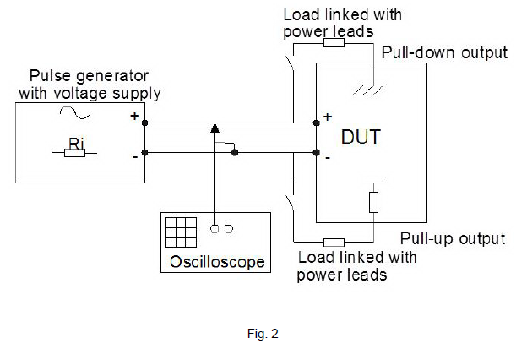

This test is intended to check the immunity of the DUT to conducted electrical transients caused by
electronic and electric components. These interferences affect power supply lines and signal or sensor
input lines when these lines are directly or indirectly connected to the power supply lines.

Unless otherwise specified, the test shall be performed in accordance with ISO 7637-2 for pulses
1, 2, 3, and ISO 16750 for pulses 4, 5.

All pulses shall be superimposed on the lines of the device(component)/system connected to the
power supply.

All test pulses shall be characterized under no-load conditions, i.e. voltages are open-loop voltages.

Table 5 FSC with respect to SI and pulse number
Choose the severity index (SI) and read the functional status classification (FSC) attached to the pulse
Pulse number | 1 | 2 | 3 | 4 | 5a ¹⁾ | 5c ²⁾
SI 1 | C | A | A | *⁾ | A | A
SI 2 | C | B | B | *⁾ | B | B
SI 3 | C | C | C | *⁾ | C | C

- This requirement is valid for 12 V systems only

- This requirement is valid for 24 V systems only

*) This is decided on a case-by-case basis, depending on unit and application

Power outputs from the unit:
- Are not allowed to be over the specified Maximum supply voltage range
- Are not allowed to be below zero volt.
- Shall be within the specified Operating voltage range if either of the supplied unit or the unit that contains the power output shall fulfill FSC A or FSC B.

Test pulse 1
Verification method VM 54523319-80 v2
Scope: This pulse originates from the switching off of an inductive load in parallel with the tested component/system, e.g. electric valves without clamp diodes.

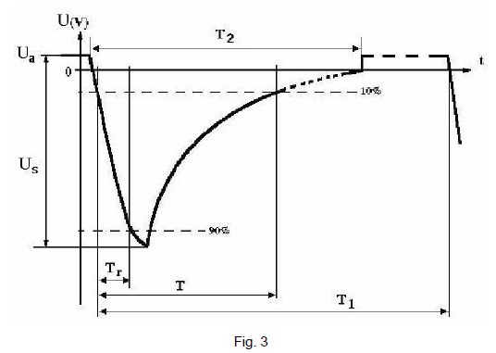

Table 6 Parameters of test pulse 1
Parameter | 24-V system | 12-V system
_{Us} (V) | -600 | -600
T_{r} (µs) | ≤ 1 | ≤ 1
T (ms) | 1 | 1
T₁ (s) | 5 | 5
T₂ (ms) | 200 | 200
R_{i} (Ω) | 50 | 50
Number of pulses | 1000 | 1000

Pass criteria:

FSC depending on severity index (see Table 5)

Test pulse 2
Verification method VM 54523319-81 v2
Scope: Pulse 2a originates from the switching off of an inductive load that is in series with the tested component/system, e.g. a DC motor. Pulse 2b simulates transients from a DC motor acting as a generator
after the ignition is switched off.
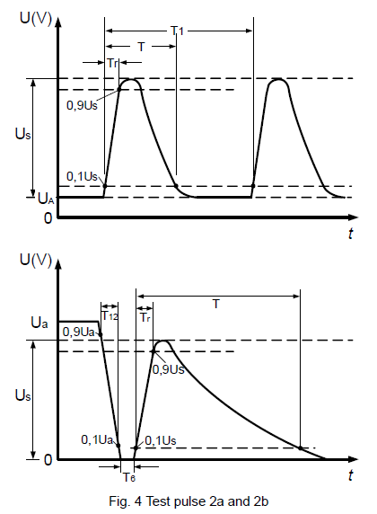

Table 7 Parameters of test pulse 2
Parameter | Test pulse 2a | Test pulse 2b
 |  | Nominal 12 V system |  |  | Nominal 24 V system
 |  | 10 |  |  | 20
_{Us} (V) | + 100
T_{r} | 1 µs | 1 ms ± 0,5 ms
T | 0,05 ms | 2 s
T₁ | 5 s | N/A
R_{i} | 10 | 0 Ω to 0,05 Ω
Number of | 1000 | 100
pulses
T₆ | N/A | 1 ms ± 0,5 ms
T₁₂ | N/A | 1 ms ± 0,5 ms

Pass criteria:

FSC depending on severity index (see Table 5)

Test pulse 3
Verification method VM 54523319-82 v2
Scope: This pulse simulates transients that occur during bouncing of a relay contact.

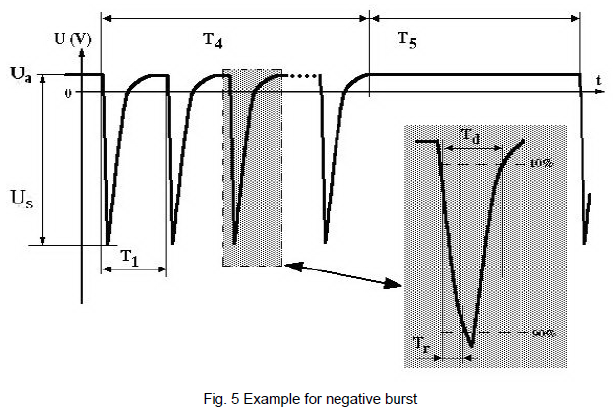

Table 8 Parameters of test pulse 3
Parameter | Pulse 3a |  | Pulse 3a |  | Pulse 3b
 | 12-V system |  | 24-V system |  | 12-V and 24-V system
U_{s} (V) | -150 |  | -200 |  | + 200
T_{r} (ns) | ≤5 |  | ≤5 |  | ≤5
T_{d} (µs) | 0.1 |  | 0.1 |  | 0.1
T1 (µs) | 100 |  | 100 |  | 100
T4 (ms) | 10 |  | 10 |  | 10
T5 (ms) | 100 |  | 100 |  | 100
_{Ri} (Ω) | 50 | 50 |  |  | 50
Test duration | 1 h | 1 h |  |  | 1 h

Pass criteria:

FSC depending on severity index (see Table 5)

Test pulse 4
Verification method VM 54523319-83 v2
Scope: This pulse originates from voltage drop on main supply due to cranking.

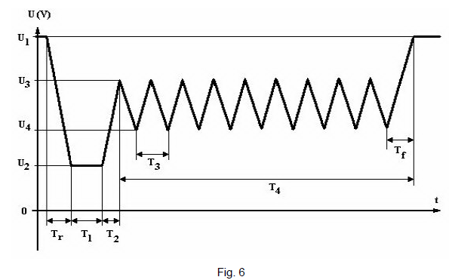

Table 9 Parameters of test pulse 4
Parameter | 12V system | 24V system
U₁* (V) | 12 | 24
U₂ (V) | 5 | 8
U₃ (V) | 10 | 18
U₄ (V) | 6 | 12
T_{r} (ms) | 5 | 10
T_{f} (ms) | 10 | 10
T₁ (ms) | 40 | 100
T₂ (ms) | 2 | 2
T₃ (ms) | 100 | 100
T₄ (s) | 20 | 20

*U₁: Value corresponding to battery state of charge of 50 %.

Pass criteria:

FSC shall be decided case by case depending on unit and application.

Test pulse 5
Verification method VM 54523319-84 v2

Scope: This pulse may be generated using a charging alternator connected to a battery with an appropriate load in parallel. The alternator speed and load should then be varied and the corresponding load dump pulse logged using an oscilloscope, the component/system not connected, to find the appropriate combination for producing the desired test pulse. The component can then be connected and the test performed.
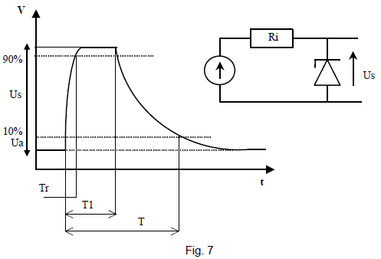
A total of five pulses shall be applied for each pulse type (a and c) tested. A period of 60 seconds shall pass between the pulses. Ua is the supply voltage according to Section 3.1.

Table 10 Parameters of test pulse 5
Test Pulse |  | Pulse 5a ¹⁾ | Pulse 5c ¹⁾
Applicability |  | 12-V system | 24-V system
Parameters | Us (V) | 25.8 | 29.5
 | Tr (ms) | ≤ 5 | ≤ 5
 | T1 (ms) | 160 | 160
 | T (ms) | 600 | 600
 | Ri (Ω) | 0.7 | 1.8

1) Alternator with internal zener diode.

Pass criteria:
FSC depending on severity index (see Table 5)

Conducted transient susceptibility on signal leads
HWC requirement REQ 54523319-48 v2

From STD 515-0003 5.2

Scope: This test is intended to ensure the immunity to transient transmission by inductive and capacitive coupling via vehicle signals or sensor cables.

A capacitive coupling clamp (CCC) is used to test capacitive coupling with fast pulses.
An inductive coupling clamp (ICC) is used to test inductive coupling with slow pulses.
The device/system shall withstand exposure to transients coupled to all signal lines. Test pulses and test methods are defined in ISO 7637-3.

Conducted transient susceptibility on signal leads fast
Verification method VM 54523319-85 v2

Fast-transient test pulses 3a and 3b

Parameters are identical to section 5.1.3 of this document (pulse 3 applied on supply leads) with the
exception of pulse amplitude and number of pulses as follows:

Pulse 3a: Us = -200 V, test time 10 minutes
Pulse 3b: Us = +200 V, test time 10 minutes

Pass criteria:

Irrespective of SI classification, FSC A is required for both pulses.

Conducted transient susceptibility on signal leads Slow
Verification method VM 54523319-86 v2

Slow-transient test pulses positive and negative 2a

According to ISO 7637-3

Test level IV

Pulse positive 2a: Us = +10 V, test time 5 minutes
Pulse negative 2a: Us = -10 V, test time 5 minutes

Pass criteria:

Irrespective of SI classification, FSC A is required for both pulses.

Power supply quality
HWC requirement REQ 54523319-49 v2

From 515-0003 5.3

Test method
A programmable power supply or a high-power operational amplifier and a signal generator may be used to generate the “saw-tooth” supply voltage. It must be able to supply both the static and dynamic currents required by the tested component/system.

As an alternative, an alternator and a partly charged battery may be used to generate the test voltage
specified in section 5.3.2. A high-power solid-state relay may be used to generate the cuts required in
section 5.3.3.

An ordinary power supply can be used to generate the test voltage specified in section 5.3.4.

Power outputs from the unit:
- Are not allowed to be over the specified Maximum supply voltage range
- Are not allowed to be below zero volt.
- Shall be within the specified Operating voltage range if either of the supplied unit or the unit that contains the power output shall fulfill FSC A or FSC B.

Power supply with battery
Verification method VM 54523319-87 v2

This test is intended to check the immunity of the device(component)/system to minimum and maximum voltages of the power system due to the regulation of the alternator.

The voltage is that encountered in a commercial vehicle, with the following characteristics:

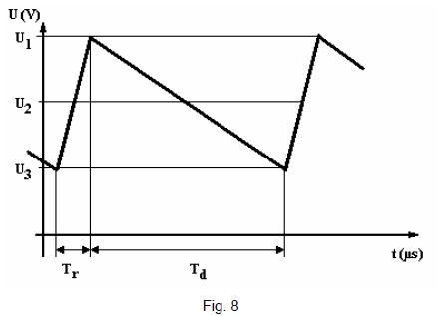

Table 11 Parameters of test voltage, power-supply quality
 | With Battery
Parameter | 12 V | 24 V
U1 [V] | 16 | 31
U2 [V] | 14.2 | 28.5
U3[V] | 11 | 26
Tr [µs] | 20 | 20
Td [µs] | 160 | 160
Test duration | 1 h | 1 h

Pass criteria:

FSC A

Power supply without battery
Verification method VM 54523319-88 v2

This test is intended to check the immunity of the device(component)/system to minimum and maximum voltages of the power system due to the regulation of the alternator.

The voltage is that encountered in a commercial vehicle, with the following characteristics:



Table 11 Parameters of test voltage, power-supply quality
 | Without Battery
Parameter | 12 V | 24 V
U1 [V] | 18 | 30
U2 [V] | 13 | 25
U3[V] | 8 | 20
Tr [µs] | 20 | 20
Td [µs] | 160 | 160
Test duration | 1 h | 1 h

Pass criteria:

FSC A

Immunity to micro power cuts
Verification method VM 54523319-89 v2

Scope: This test comes from problems with logic control circuits due to short-duration power cuts causing software-related problems.

The power supply of the tested component/system shall undergo micro power cuts as stipulated in the component TR. Unless otherwise specified, tests with a power cut duration (tinterrupt) of 100, 200 and 400 μs shall be applied 5 times, with a >1 s delay between each power cut. Waveform transition times shall be approximately 10 μs and the voltage drop shall be from nominal operating voltage, Usnom to 0 V. For illustration of the test pulse, see the figure below.

The test harness connecting the DUT to the test fixture and transient pulse generator shall be
≤ 2000 mm in length.

During the micro power cut, the supply line shall be in open circuit.
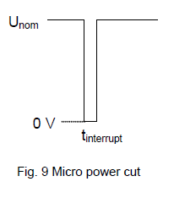

Pass criteria:

A component/system shall be capable of uninterrupted operation when micro power cuts are applied (FSC A).

Immunity to high-voltage supply
Verification method VM 54523319-90 v2
Scope: This test comes from battery chargers/starters used in combination with batteries in poor condition.
This will result in a rise of the supply voltage.

A component shall be immune to high voltage in the supply lines for a certain amount of time. This simulates a quick charger/starter.

Table 12 Requirements per electrical system and test

Table 12 Requirements per electrical system and test
12-V systems
Test name | U, supply | T, duration | Requirement
Charger/starter | 24 V | 5 min | FSC D
24-V systems
Test name | U, supply | T, duration | Requirement
Charger/starter | 48 V | 2 min | FSC D

Pass criteria:
FSC D

Radiated emission CV (Complete Vehicle)

HWC requirement REQ 54523319-50 v2

From 515-0003-6.1

Radiated emissions measured at the foot of the antenna – Test
Verification method VM 54523319-91 v2

Reference document
The components shall comply with the requirements defined in CISPR 25, Edition 05 or as agreed.

Field of application
This test is intended to evaluate the level of electromagnetic disturbance received by the vehicle’s antennas.

Principal characteristics:
- Frequency band [150 kHz – 3,0 GHz]
- Peak and average detectors shall always be used.
- Peak and average detection are used to measure compliance with both average and peak limits.

Comments:

Frequency bands outside of CISPR 25 bands are also included, not shaded in the table.

In the 30–3000 MHz range with 100/120 kHz bandwidth, the measurements using average detector can be conducted with a bandwidth of 9/10 kHz if the ambient electromagnetic noise level measured at 100/120 kHz is not at least 6 dB lower than the applicable limit.

Unless otherwise defined in CISPR 25, Edition 05 or as agreed, the measurement time (receiver) or sweep time (spectrum analyzer) shall be increased if low recursive frequency must be measured.

Based on the type of possible receivers (depending on vehicle range and region), the tests can be carried out with the specific frequency bands specified by the EMC responsible at Volvo. This will be decided on a case-by-case basis.

In case of an overlap between bands, the lower limit shall apply.

Radiated levels

To protect on-board receivers, the disturbance voltage at the end of the antenna cable shall not exceed the values in table 13.

Table 13
Band |  |  | Frequency band (MHz) | Peak detector |  | Average detector
 |  |  |  | Limit value dB(µV) | BW (kHz) | Limit value dB(µV) | BW (kHz)
LW |  | 1) | 0,15–0,30 | 26 | 9/10 | 20 | 9/10
2) |  |  | 0,30–0,53 | 26 | 9/10 | 20 | 9/10
MW |  | 1) | 0,53–1,8 | 22 | 9/10 | 10 | 9/10
2) |  |  | 1,8–5,9 | 22 | 9/10 | 10 | 9/10
SW |  | 1) | 5,9–6,2 | 22 | 9/10 | 10 | 9/10
2) |  |  | 6,2–26 | 22 | 9/10 | 10 | 9/10
CB |  | 3) | 26–28 | 22 | 9/10 | 0 | 9/10
2) |  |  | 28–30 | 22 | 9/10 | 0 | 9/10
VHF |  | 3) | 30–54 | 20 | 100/120 | 0 | 100/120
TV Band 1 |  | 1) | 41–88 | 16 | 100/120 | 6 | 100/120
VHF |  | 3) | 68–87 | 20 | 100/120 | 0 | 100/120
FM |  | 1) | 76–108 | 26 | 100/120 | 6 | 100/120
2) |  |  | 108–137 | 26 | 100/120 | 6 | 100/120
VHF |  | 3) | 137–175 | 20 | 100/120 | 0 | 100/120
TV Band 3 |  | 1) | 174–230 | 16 | 100/120 | 6 | 100/120
DAB 3 |  | 1) | 171–245 | 10 | 100/120 | 0 | 100/120
2) |  |  | 245–300 | 20 | 100/120 | 6 | 100/120
RKE |  | 3) | 300–330 | 20 | 100/120 | 6 | 100/120
2) |  |  | 330–380 | 20 | 100/120 | 6 | 100/120
RKE |  | 3) | 420–450 | 20 | 100/120 | 6 | 100/120
UHF |  | 3) | 380–512 | 20 | 100/120 | 0 | 100/120
DTTV |  | 1) | 470–770 | 20 | 100/120 | 10 | 100/120
TV Band 4/5 |  | 1) | 468–944 | 16 | 100/120 | 6 | 100/120
UHF |  | 3) | 820–960 | 20 | 100/120 | 0 | 100/120
GSM 800 | 3) |  | 860–895 | 26 | 100/120 | 6 | 100/120
GSM 900 | 3) |  | 925–960 | 26 | 100/120 | 6 | 100/120
2) |  |  | 960–1447 | 26 | 100/120 | 6 | 100/120
DAB L BAND 1) |  |  | 1447–1494 | 10 | 100/120 | 0 | 100/120
2) |  |  | 1494–1567 | 20 | 100/120 | 0 | 100/120
GPS | 3) |  | 1567–1583 | 20 | 100/120 | 0 | 100/120
2) |  |  | 1583–1803 | 26 | 100/120 | 6 | 100/120
GLONASS | 3) |  | 1591–1616 | 20 | 100/120 | 0 | 100/120
GSM 1800 | 3) |  | 1803–1882 | 26 | 100/120 | 6 | 100/120
GSM 1900 | 3) |  | 1850–1990 | 26 | 100/120 | 6 | 100/120
UMTS (3G) | 3) |  | 1900–2172 | 26 | 100/120 | 6 | 100/120
2) |  |  | 2172–2320 | 26 | 100/120 | 6 | 100/120
SDARS | 1) |  | 2320–2345 | 16 | 100/120 | 6 | 100/120
2) |  |  | 2345–2400 | 16 | 100/120 | 6 | 100/120
Bluetooth /WLAN  3) |  |  | 2400–2500 | 26 | 100/120 | 6 | 100/120
2) |  |  | 2500–3000 | 26 | 100/120 | 6 | 100/120

1) Broadcast
2) Free band
3) Mobile services band

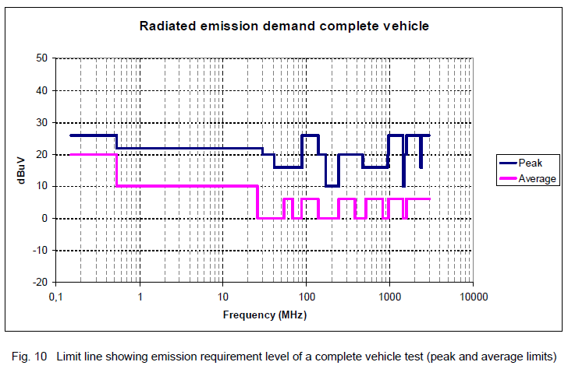
Pass criteria:
According to Table 13, no limit excess is allowed.

Radiated emissions measured in accordance with ECE R10 - Test
Verification method VM 54523319-92 v2
The test methods are in accordance with ECE R10 with the following setup:

- Frequency band [30 MHz – 2 GHz]
- Horizontal and vertical polarization
- Limits according to table 14 and table 15

References levels

The vehicle shall comply with the requirements stated in table 14 and table 15.
Measurements at 3 meters or 10 meters:

Table 14 Peak and average when antenna-vehicle separation is 3 meters
Frequency (MHz) | Peak detector limit (dBµV/m) | Average detector limit  (dBµV/m)
30–75 | 54 | 32
75–400 | 54 + 15,13·log (F/75) | 32 + 15,13·log (F/75)
400–2000 | 65 | 43

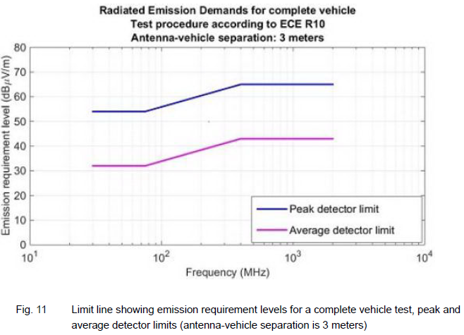
Table 15 Peak and average when antenna-vehicle separation is 10 meters
Frequency (MHz) | Peak detector limit (dBµV/m) | Average detector limit (dBµV/m)
30–75 | 44 | 22
75–400 | 44 + 15,13·log (F/75) | 22 + 15,13·log (F/75)
400–2000 | 55 | 33

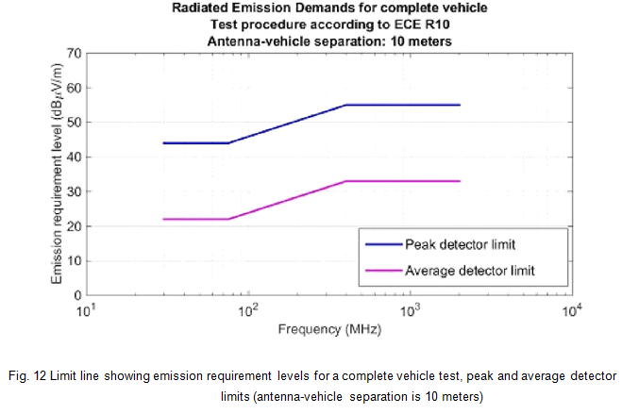

Pass criteria:

According to Table 14 and 15, no limit excess is allowed.

Radiated emission
HWC requirement REQ 54523319-51 v2

From 515-0003 6.2

Reference document
The components shall comply with the requirements defined in CISPR 25, Edition 05 or as agreed.

Field of application
This test is intended to evaluate radio frequency emitted disturbances generated by the DUT and its wiring.

Radiated emission ALSE

Verification method VM 54523319-93 v2
Principal characteristics:

- Peak detector and average detector shall always be used. Peak and average detection are used to measure compliance with both average and peak limits.
- Frequency band [150 kHz – 3,0 GHz].
- Frequency bands outside of CISPR 25 bands are included, not shaded in the table.

- In the range 30–3000 MHz with 100/120 kHz bandwidth, the measurements using average detector can be conducted with a bandwidth of 9/10 kHz if the ambient electromagnetic noise level measured at 100/120 kHz is not at least 6 dB lower than the applicable limit.
- Unless otherwise defined in CISPR 25, Edition 05 or as agreed, the measurement time (receiver) or sweep time (spectrum analyzer) shall be increased if low recursive frequency shall be measured.
- In case of an overlap between bands, the lower limit shall apply.

In a component test, the actuator, sensors, switches, etc., connected to the tested component/system shall, as far as possible, be the same as those used in production.
In a component test, the component/system with its actuator, sensors, switches, etc., shall be connected to the ground plane in the same way as the vehicle installation.
References levels
The device(component)/system shall comply with the requirements in table 16.

Table 16
Band |  | Frequency |  | Peak detector |  |  |  |  | Average detector
 |  | band (MHz)
 |  |  |  | Limit value |  |  | BW (kHz) |  | Limit value |  |  | BW (kHz)
 |  |  |  | dB(µV/m) |  |  |  |  | dB(µV/m)
LW1 | 1) | 0,15–0,30 |  | 46 |  |  | 9/10 | 26 |  |  |  | 9/10
 | 2) | 0,30–0,53 | 46 |  |  |  | 9/10 | 26 |  |  | 9/10
MW | 1) | 0,53–1,8 |  | 40 |  |  | 9/10 | 20 |  |  |  | 9/10
 | 2) | 1,8–5,9 | 40 |  |  |  | 9/10 | 20 |  |  | 9/10
SW | 1) | 5,9–6,2 |  | 40 |  |  | 9/10 | 20 |  |  |  | 9/10
 | 2) | 6,2–26 | 40 |  |  |  | 9/10 | 20 |  |  | 9/10
CB | 3) | 26–28 |  | 40 |  |  | 9/10 | 20 |  |  |  | 9/10
 | 2) | 28–30 | 40 |  |  |  | 9/10 | 20 |  |  | 9/10
VHF | 3) | 30–54 |  | 40 |  |  | 100/120 | 20 |  |  |  | 100/120
TV Band 1 | 1) | 41–88 |  | 28 |  |  | 100/120 | 18 |  |  |  | 100/120
VHF | 3) | 68–87 |  | 35 |  |  | 100/120 | 15 |  |  |  | 100/120
FM | 1) | 76–108 |  | 38 |  |  | 100/120 | 18 |  |  |  | 100/120
 | 2) | 108–137 | 38 |  |  |  | 100/120 | 18 |  |  | 100/120

Band |  |  | Frequency |  |  |  | Peak detector |  |  |  |  |  | Average detector
 |  |  | band (MHz)
 |  |  |  |  |  |  | Limit value |  |  |  | BW (kHz) |  | Limit value |  |  | BW (kHz)
 |  |  |  |  |  |  | dB(µV/m) |  |  |  |  |  | dB(µV/m)
VHF | 3) |  | 137–175 |  |  |  | 35 |  |  |  | 100/120 |  | 15 |  |  |  |  | 100/120
TV Band 3 | 1) |  | 174–230 |  |  |  | 32 |  |  |  | 100/120 |  | 22 |  |  |  |  | 100/120
DAB 3 | 1) |  | 171–245 |  |  |  | 26 |  |  |  | 100/120 |  | 16 |  |  |  |  | 100/120
RKE | 3) |  | 300–330 |  |  |  | 32 |  |  |  | 100/120 |  | 18 |  |  |  |  | 100/120
 |  | 2) | 330–380 | 32 |  |  |  |  |  |  |  | 100/120 |  | 18 |  |  | 100/120
RKE |  | 3) | 420–450 |  |  | 32 |  |  |  |  |  | 100/120 |  | 18 |  |  | 100/120
UHF |  | 3) | 380–512 |  |  | 38 |  |  |  |  |  | 100/120 |  | 18 |  |  | 100/120
DTTV |  | 1) | 470–770 |  |  | 45 |  |  |  |  |  | 100/120 |  | 35 |  |  | 100/120
TV Band 4/5 |  | 1) | 468–944 |  |  | 41 |  |  |  |  |  | 100/120 |  | 31 |  |  | 100/120
UHF |  | 3) | 820–960 |  |  | 44 |  |  |  |  |  | 100/120 |  | 24 |  |  | 100/120
GSM 800 |  | 3) | 860–895 |  |  | 44 |  |  |  |  |  | 100/120 |  | 24 |  |  | 100/120
GSM 900 |  | 3) | 925–960 |  |  | 44 |  |  |  |  |  | 100/120 |  | 24 |  |  | 100/120
 |  | 2) | 960–1447 | 44 |  |  |  |  |  |  |  | 100/120 |  | 24 |  |  | 100/120
DAB L BAND |  | 1) | 1447–1494 |  | 28 |  |  |  |  |  |  | 100/120 |  | 18 |  |  | 100/120
 |  | 2) | 1494–1567 | 44 |  |  |  |  |  |  |  | 100/120 |  | 18 |  |  | 100/120
GPS |  | 3) | 1567–1583 |  |  |  |  | 44 |  |  |  | 100/120 |  | 10 |  |  | 100/120
 |  | 2) | 1583–1803 | 44 |  |  |  |  |  |  |  | 100/120 |  | 24 |  |  | 100/120
GLONASS |  | 3) | 1591–1616 |  |  |  |  | 44 |  |  |  | 100/120 |  | 10 |  |  | 100/120
GSM 1800 |  | 3) | 1803–1882 |  |  |  |  | 44 |  |  |  | 100/120 |  | 24 |  |  | 100/120
GSM 1900 |  | 3) | 1850–1990 |  |  |  |  | 44 |  |  |  | 100/120 |  | 24 |  |  | 100/120
UMTS (3G) |  | 3) | 1900–2172 |  |  |  |  | 44 |  |  |  | 100/120 |  | 24 |  |  | 100/120
 |  | 2) | 2172–2320 | 44 |  |  |  |  |  |  |  | 100/120 |  | 24 |  |  | 100/120
SDARS |  | 1) | 2320–2345 |  |  |  |  | 34 |  |  |  | 100/120 |  | 24 |  |  | 100/120
 |  | 2) | 2345–2400 | 44 |  |  |  |  |  |  |  | 100/120 |  | 24 |  |  | 100/120
Bluetooth /WLAN 3) |  |  | 2400–2500 |  |  |  |  | 44 |  |  |  | 100/120 |  | 24 |  |  | 100/120
 |  | 2) | 2500–3000 | 44 |  |  |  |  |  |  |  | 100/120 |  | 24 |  |  | 100/120

- Broadcast

- Free band

- Mobile services band

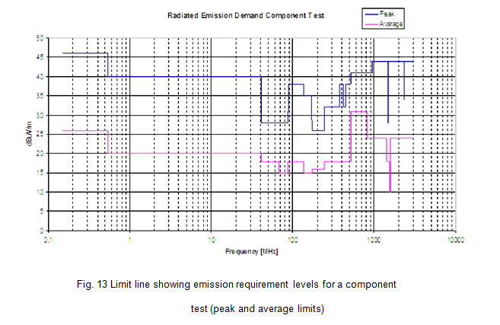

Pass criteria:

According to Table 16, no limit excess is allowed.

General - Radiated susceptibility

HWC requirement REQ 54523319-52 v2

From 515-0003 7.1

The frequency range where the radiated susceptibility requirements apply is 150 kHz – 3 GHz, with the additional radar frequency bands up to 12,4 GHz.

- Substitution method with the conservation of peak level
- Semi-anechoic or anechoic chamber shall be used

Modulation vs frequency range:

- CW in the 150 kHz – 3 GHz range
- AM in the 150 kHz – 800 MHz range
- PM1 in the 800 MHz – 3 GHz range
- PM2 in the 1,15–1,45 GHz range, L-band
- PM2 in the 2,6–3,2 GHz range, S-band
- PM2 in the 5,2–5,9 GHz range, C-band
- PM2 in the 8,2–12,4 GHz range, X-band

According to ISO 11451-1 and ISO 11452-1

According to ISO 11451-1 and ISO 11452-1

- Non-modulated signal: continuous wave (CW)
- Amplitude modulated (AM): 1 kHz 80 %
- Pulse-modulated 1 (PM1): Ton 577 µs, period 4600 µs
- Pulse-modulated 2 (PM2): Ton 3 µs, period 3333 µs
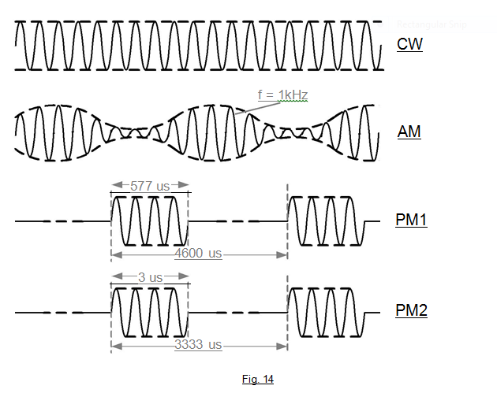

To confirm that the vehicle/component meets the requirements in this section, the vehicle/component shall be tested with the following maximum frequency steps:
- From 150 kHz to 1 MHz: step 30/decade
- From 1 MHz to 20 MHz: step 0,5 MHz
- From 20 MHz to 220 MHz: step 1 MHz
- From 220 MHz to 500 MHz: step 2 MHz
- From 500 MHz to 1 GHz: step 5 MHz
- From 1 GHz to 3 GHz: step 20 MHz
- L-band, from 1,15–1,45 GHz: step 5 MHz
- S-band, from 2,6–3,2 GHz: step 5 MHz
- C-band, from 5,2–5,9 GHz: step 10 MHz
- X-band, from 8,2–12,4 GHz: step 20 MHz

At each frequency, the field amplitude shall be applied as follows:
- From 0 V/m to the maximum
- Constant during X seconds
- From maximum to 0 V/m.

The amplitude modulation is effective during the constant part of the cycle. Time X shall be sufficient to
allow the device(component)/system under test to react to the interference and for any reaction to be recorded; X shall never be less than 2 seconds.

Vertical and horizontal polarization shall be used above 20 MHz.

Table 17. FSC requirements and test levels

Severity index |  | SI 1 | SI 2 | SI 3
Test level | III | A | B | D
 | II | A | A | C
 | I | A | A | A

Observe the defined severity index (SI) as defined in the component’s technical regulation.
Observe the defined functional status classification (FSC) for each level.
Carry out the different test levels and check FSC compliance.

Radiated susceptibility CV (Complete Vehicle) - Test
Verification method VM 54523319-94 v2
A complete vehicle test shall conform to ISO 11451-2 and ISO 11451-3.

Table 18 Test levels with respect to test methods
Test method | Applicable standard | Test level (V/m)
 |  | Level I | Level II | Level III
Vehicle test, far field | ISO 11451-2 | 30 | 50 | 100
On-board transmitter simulation | ISO 11451-3 | See tables A.1 and A.2 of  ISO 11451-3

Radiated susceptibility component - Test
Verification method VM 54523319-95 v2
The components shall comply with the following requirements.

The applicable frequency range for this test method is 150 kHz – 3000 MHz, and L-, S-, C-, X-bands
(including both far field and BCI test methods). Testing over the full frequency range could require
different field-generating devices, but this does not imply that testing of overlapping frequency ranges
is required. Only test methods described in table 19 are accepted.

Table 19 Test levels with respect to test methods

Test method | Applicable | Test level
 | standard | Level I | Level II | Level III
Far field (V/m), 200–3000 MHz | ISO 11452-2 | 30 | 50 | 100

Pass criteria:

FSC depending on severity index (see Table 17)

Radiated susceptibility component test -Far field Radar
Verification method VM 54523319-96 v2
The components shall comply with the following requirements.
The applicable frequency range for this test method is 150 kHz – 3000 MHz, and L-, S-, C-, X-bands (including both far field and BCI test methods). Testing over the full frequency range could require different field-
generating devices, but this does not imply that testing of overlapping frequency ranges is required.
Only test methods described in table 20 are accepted.

Table 20 Test levels with respect to test methods
Test method | Applicable | Test level
 | standard | Level I | Level II | Level III
Far field (V/m), L-band | ISO 11452-2 | 200 | 600 | N/A
Far field (V/m), S-band | ISO 11452-2 | 100 | 200 | N/A
Far field (V/m), C-band | ISO 11452-2 | 100 | 200 | N/A
Far field (V/m), X-band | ISO 11452-2 | 100 | 200 | N/A

Pass criteria:

FSC depending on severity index (see Table 17)

Radiated susceptibility component test -BCI
Verification method VM 54523319-97 v2
The components shall comply with the following requirements.

The applicable frequency range for this test method is 150 kHz – 3000 MHz, and L-, S-, C-, X-bands (including both far field and BCI test methods). Testing over the full frequency range could require different field-generating devices, but this does not imply that testing of overlapping frequency ranges is required. Only test methods described in table 21 are accepted.

Table 21 Test levels with respect to test methods

Test method | Applicable | Test level
 | standard | Level I | Level II | Level III
BCI test* (mA), 150 kHz – 400 MHz | ISO 11452-4 | 60 | 100 | 200

*)When using the closed-loop method with limitation of forward power, K = 4 shall be used. When using substitution method, all 3 positions (150 mm, 450 mm, 750 mm) shall be used. If multiple harnesses or connectors are used, a test shall be performed for each harness/connector.

Pass criteria:

FSC depending on severity index (see Table 17)

Simulated portable transmitter
Verification method VM 54523319-98 v2
This test is applicable for electrical and electronic components that can be located close to handheld transmitters (e.g. cellular phone). For each component, Volvo shall evaluate and determine if this test needs to be performed. This test should be performed according to ISO 11452-9, excluding the frequency ranges for “10 m”, “2 m” and “IEEE 802.11a”.

Pass criteria:

According to Table A.1 of ISO 11452-9

Immunity to electrostatic discharge

HWC requirement REQ 54523319-53 v2

From 515-0003 8

This test is intended to check the immunity of components to electrostatic discharges produced:
- by operators during storage, handling, assembly and maintenance. Unpowered test is required.
- by occupants in or near the vehicle and customer service operation. Powered test is required.

The electrostatic discharge immunity test procedure shall be conducted using ISO 10605 with the following
conditions and requirements.

Immunity to ESD Handling

Verification method VM 54523319-99 v2

This test is intended to check the immunity of components to electrostatic discharges produced:
- by operators during storage, handling, assembly and maintenance. Unpowered test is required.
- by occupants in or near the vehicle and customer service operation. Powered test is required.

The electrostatic discharge immunity test procedure shall be conducted using ISO 10605 with the following

conditions and requirements.

Tests | Direct contact  Discharge sequence | Air contact  Discharge sequence | Specifications
Component test:  Unpowered tests (handling) | ± 4 / 8 KV  On each connector pin²⁾ and conductive surface of the device (component) / system | ± 4 / 8 / 15 / (30)¹⁾ KV  On all accessible points and other surfaces of the device (component) / system | Supplier test  Sequence with a series of 10 discharges for each negative and positive level (from the lowest level to the highest level)  Intervals between each discharge:  5s minimum  Network: R = 330 Ω, C = 150 pF
Requirements:
FCS A AFTER RECONNECTION

- Only for pyrotechnic components.
- For testing pins in contact mode, an extension line for easy discharge can be used. The line shall be no longer than 25 mm.

Pass criteria:

FSC A after reconnection

Immunity to ESD Powered
Verification method VM 54523319-100 v2
This test is intended to check the immunity of components to electrostatic discharges produced:

- by operators during storage, handling, assembly and maintenance. Unpowered test is required.
- by occupants in or near the vehicle and customer service operation. Powered test is required.

The electrostatic discharge immunity test procedure shall be conducted using ISO 10605 with the following

conditions and requirements.

Tests | Direct contact  Discharge sequence | Air contact  Discharge sequence | Specifications
Component test:  Powered-up tests  (live and loaded  conditions) | ± 4 / 8 KV  (Device(component)/system and remote  inputs/outputs)²⁾  On all points accessible by vehicle occupants during maintenance and operation (determined in the test plan) | ± 4 / 8 / 15 / (25)¹⁾ KV  (Device(component)/ system and remote inputs/outputs)²⁾  On all points accessible by vehicle occupants during maintenance and  operation (determined in the test plan) | Supplier test  Sequence with a series  of 10 discharges for  each negative and  positive level (from the  lowest to the highest level)  Intervals between each discharge: 5 s minimum  Network: R = 330 Ω, C = 330 pF (150 pF)ª
Requirements:
± 4 / 8 KV: FSC A for severity indices 1 and 2, FSC B for severity index 3
± 15 / (25)1) KV: FSC B for severity indices 1 and 2, FSC C for severity index 3

- Only for pyrotechnic components.
- For powered-up tests, the device(component)/system shall be connected to all inputs/outputs necessary for functional testing, as well as controls, actuators, sensors, etc.

All discharge sequences also apply to:

- All devices(components)/systems directly connected to the unit and accessible by vehicle occupants during maintenance and operation, as well as remote control, switches, displays, harness, connectors, etc.

- All inputs/outputs that are connected to communication buses and regarded as accessible points (e.g.: diagnostic plug, OBD plug). In that case C = 150 pF; note ª

- All devices(components)/systems directly connected to the unit may be subject to ESD indirectly by a charged source (e.g., wheel speed sensor, external temperature sensor, etc.)

In agreement with Volvo, if a periphery is not available for the test, the connecting lines shall be tested directly with discharges.

Pass criteria:
± 4 / 8 KV: FSC A for severity indices 1 and 2, FSC B for severity index 3
± 15 / (25)1) KV: FSC B for severity indices 1 and 2, FSC C for severity index 3

Immunity to ESD Complete vehicle
Verification method VM 54523319-101 v2
This test is intended to check the immunity of components to electrostatic discharges produced:
- by operators during storage, handling, assembly and maintenance. Unpowered test is required.
- by occupants in or near the vehicle and customer service operation. Powered test is required.

The electrostatic discharge immunity test procedure shall be conducted using ISO 10605 with the following conditions and requirements.

Vehicle test | If needed  Test plan, specifications and requirements defined by the EMC engineering department  Contact discharge: ± 4 / 8 KV  Air discharge: ± 4 / 8 / 15 / (25)¹⁾ KV | Vehicle manufacturer  Test  Network: R = 330 Ω, C = 150 / 330 pF²⁾
Requirements:
± 4 / 8 KV: FSC A for severity indices 1 and 2, FSC B for severity index 3
± 15 / (25)1) KV: FSC B for severity indices 1 and 2, FSC C for severity index 3

- Only for pyrotechnic components.
- C = 330 pF for areas that can only be touched from the inside of the vehicle.
- C = 150 pF for areas that can only be touched from the outside of the vehicle.
Pass criteria:
± 4 / 8 KV: FSC A for severity indices 1 and 2, FSC B for severity index 3
± 15 / (25)1) KV: FSC B for severity indices 1 and 2, FSC C for severity index 3

Pre damage ESD
Verification method VM 54523319-102 v2

This test is intended to check the immunity of components to electrostatic discharges produced:
- by operators during storage, handling, assembly and maintenance. Unpowered test is required.
- by occupants in or near the vehicle and customer service operation. Powered test is required.

The electrostatic discharge immunity test procedure shall be conducted using ISO 10605 with the following conditions and requirements.

Tests | Direct contact  Discharge sequence | Air contact  Discharge sequence | Specifications
Component test:  Unpowered tests (handling) | ± 4 / 8 KV  On each connector pin²⁾ and conductive surface of the device (component) / system | ± 4 / 8 / 15 / (30)¹⁾ KV  On all accessible points and other surfaces of the device (component) / system | Supplier test  Sequence with a series of 10 discharges for each negative and positive level (from the lowest level to the highest level)  Intervals between each discharge:  5s minimum  Network: R = 330 Ω, C = 150 pF
Requirements:
FCS A AFTER RECONNECTION

- Only for pyrotechnic components.
- For testing pins in contact mode, an extension line for easy discharge can be used.

- The line shall be no longer than 25 mm.

Pass criteria:

No notisable damage

Immunity to low-frequency magnetic fields

HWC requirement REQ 54523319-54 v2

From 515-0003 9.1

Scope: This requirement serves to protect systems from interference from power lines, their harmonics
and DC fields present at certain industrial plants. Conforms to ISO 11452-8.

The following requirements are applicable to magnetic fields of zero and low frequencies from 15 Hz up to 150 kHz.

Immunity to low-frequency magnetic fields

Verification method VM 54523319-103 v2

Test levels:

DC field : 25 mT

AC field (15 Hz to 150 kHz): according to ISO 11452-8, test level IV (internal field)

The frequency steps shall be at least 10/decade, linear or logarithmic. If any resonance frequency of the
system can be suspected, the number of steps shall be increased to at least 80 steps/decade,
algorithmic steps, or 3 % step size.

Pass criteria:
System with SI 1: FSC A must be maintained throughout the test.
System with SI 2 or SI 3: At least FSC C must be maintained.

Emission of low-frequency magnetic fields
HWC requirement REQ 54523319-55 v2

From 515-0003 9.2

Test setup complete vehicle
Verification Method VM 54523319-104 v2
This test will be performed by Volvo.
The magnetic field shall be measured in accordance with the following test set-up.
The following conditions shall be fulfilled:
- Headlights on
- Radio turned on
- Fan on half speed
- Cab lights turned on
The measurements shall be carried out both at idle and at 2000 rpm, driver and passenger side. The measurement points shall be in accordance with fig. 15, except the bunk location.

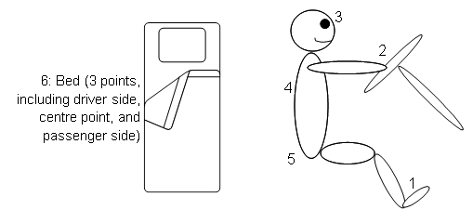

Fig. 15
Measurement shall also be carried out at measurement point 6 with the engine shut off.
Pass criteria:
Frequency range RMS value (must never be exceeded)
5 Hz - 2 kHz 2,0 µT
2 kHz - 400 kHz 0,25 µT

Network/communication
TR information INF 54523319-35 v2
Not applicable for any component not connecting to a Volvo network or communications bus.

Diagnostics and control
TR information INF 54523319-36 v2
The aurora system should support component-level diagnostics and report any failure to Volvo system.

Diagnostics – Design review
Verification method VM 54523319-105 v2
To be reviewed with stakeholders.
Pass criteria
Documented/stated compliance with requirements.

Manufacturing and logistics

Part handling by GTO/AM
TR information INF 54523319-37 v2
If any of the COTS components are dropped during manufacturing or aftermarket, the part shall not be installed and shall be returned to Aurora. This is a requirement towards Aurora to make sure this information is added to the PHR (Part Handling Request).

Component design for assembly
HWC requirement REQ 54523319-56 v2
The component shall support production requirements on safety and ergonomics:
- Be free from sharp edges
- Secure hand insertion force (as shown in chart below)

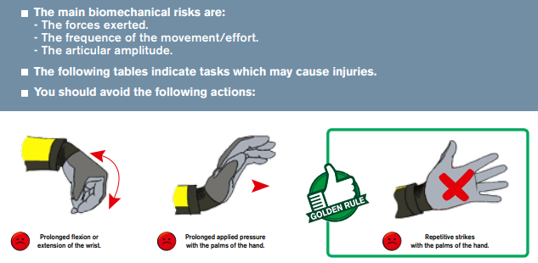
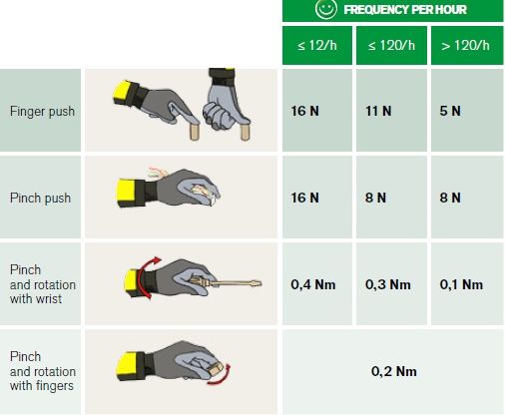

- Component design shall allow visibility of assembly operations, no hidden assembly allowed
- Component and fastener design shall allow tightening tool accessibility
- Be easy to attach to a fixture, if applicable (assembly / control fixture)
- Secure clearance between connectors for hand accessibility (30mm)
- The use of glue to assemble parts in Volvo plant shall be prohibited
- Sticking with tape shall be restricted but is acceptable IF conditions are well documented (for ex film antenna or toll collect equipment sticking on windscreen, shall have indication marks on the windscreen)

The component shall support production requirements on industrial capacity and flexibility and in handling and quality:
- Have a minimum of materials, variants and part numbers
- Process emissions and substance usage shall be designed within regulatory and Volvo requirements Do not design a product that requires a process that includes hazardous waste in our factories (eg, solvents, wipes,fill fluids,…)
- Module assembly and sub assembly shall be possible without flipping the module during assembly
- Minimize exposed fiberglass or other substances causing iritation to operator skin, eyes, or respiratory tract.
- Support shortest possible assembly time by minimizing fasteners and implementing quick connect solutions
(e.g : signal, power supply, ground, coolant pipes)
- Support standard tools by using Volvo global fasteners
- Require a minimum of assembly tools by using same fasteners and torque
- Provide tool points for lifting tool
- Ease installation, interface connections and secure quality by supporting:
  - One motion installation and connection (no twist)
  - Self-locating installation (before tightening)
  - Color marks
  - Poka-Yoke
  - No gap and flush, alignment adjustment
  - Connector sensory (e.g: haptic, sound) feedback and locking system
  - No tool required for electrical connection
- Support standalone (i.e: without gateway) programming and diagnostic via manufacturing Off-board diagnostic tool.
- Support coolant filling and verification process: withstand 1.65 bar pressure and 10 mbar (absolute) for vacuum (if applicable).
- All critical characteristics assembly shall be identified
- No specific ESD equipment (e.g : ESD shoes, floor mats, gloves,…) required when handling the component
- Connector locking only when 100% electrical connected with well-defined visual and audio “click” feedback (haptic feedback)
- No tool shall be required for electrical connection. If a ring terminal interface is used a lock rotation is required.

Component design for assembly – Design review
Verification method VM 54523319-106 v2
The fulfilment of assembly requirements shall be discussed and approved before B-release.
Fulfilment of the requirements shall be documented.

The following is required before B-release:
The supplier shall provide Volvo with a description of the mounting interface, including dimensions and tolerances.
The supplier shall provide Volvo with complete installation requirements and, if any, limitation of use for the component in relation to Volvo requirements.
Pass criteria
Documented/stated compliance with requirements.

Component design for logistics
HWC requirement REQ 54523319-57 v2
The component shall fulfil the following design-for-logistics requirements:
- The component shall fit into Volvo standard packaging (V-EMB) according to the V-EMB design boxes matrix.
- If the component is larger than Volvo standard packaging (V-EMB), it shall fit into standard transport carriers.
- The component design shall be optimized in order to increase and maximize the filling rate in transport packaging.
- The component shall be optimized for transportation and handling prior to assembly:
  - For ex: Protection plug (for hydraulic holes, or for fragile lens)?
  - For ex: Self protecting case to ease component manipulating and reduce damages, if relevant (minimizing trash)
- No or simplest protection shall be needed during transportation
- When requested by GTO, new part shall be marked with 2D code according to Volvo STD 103-0013. GTO marking requests will be communicated on SL1, SL2 and Component level before CG.
- No incoming part / emballage with dimension exceeding standard trailer interior dimension of 89" width

Component design for logistics – Design review
Verification method VM 54523319-107 v2
The component design-for-logistics review shall be initiated and discussed before Concept Gate and verified/approved with design-for-logistics stakeholders before B-release.

Pass criteria
Documented/stated compliance with requirements.
The fulfilment of requirements shall be documented in the Design for Logistics Conclusion Report.

Aftermarket

Design for aftermarket
TR information INF 54523319-38 v2
A new part is backward-compatible if it can replace preceding parts in all previous applications. If Aurora components have any effect on volvo components, it should be coordinated with any other project workgroups focusing on this area.

HWC requirement REQ 54523319-58 v2
Backward-compatibility solution
[Requirement To Be Defined]

Spare part assortment
[Requirement To Be Defined]

Design for aftermarket – Design review
Verification method VM 54523319-108 v2
Fulfilment of the requirements is verified by a DFaM (Design For aftermarket) review.
Pass criteria
Documented/stated compliance with requirements.

Cybersecurity

Cybersecurity Engineering
HWC requirement REQ 54523319-59 v2
If any of the COTS components provided by Aurora are subject to cybersecurity concerns or tampering, then Aurora shall supply a TARA describing the threats and recommended actions for the vehicle platform.

Cybersecurity engineering – Design review
Verification method VM 54523319-109 v2
Verified against IEC 62443-3-3, or as agreed within the program Cybersecurity workgroup.

RTS to state the method of verification.

Cybersecurity supply chain management
HWC requirement REQ 54523319-60 v2
A software bill of material shall be provided for any component in the assembly containing software.
The required artefact shall include all software components (proprietary and open source), open source licenses, and dependencies included in the delivered hardware component.

Cybersecurity engineering - Design review
Verification method VM 54523319-110 v2
Software bill of material to be shared with the program cybersecurity workgroup.

Other requirement areas

Marking
HWC requirement REQ 54523319-61 v2
The component packaging or emballage shall be marked for (one or more of) the following reasons:
- Identification marking, according to Volvo STD 5051,16 Text marking on parts, and MET code
VT: 4.4 - 1G – HPU (To be discussed during RTA and TRA)

- Legal marking (E.g., if applicable, type-approval markings)
- Any legal marking required is under the responsibility of the supplier.
Any other marking on the component than that specified in the TR shall require explicit approval from Volvo.

Marking – Design review
Verification method VM 54523319-110 v2
The need for marking shall be identified during RTS.
Marking shall be clearly indicated in the design-engineering documentation (drawings), in accordance with the applicable STD (see requirement) prior to C-release.

Pass criteria
Documented/stated compliance with requirements.

References

Reference documents
TR information INF 54523319-39 v2
The following table lists all documents that this TR refers to.

Document | Description | Issue/ Version
Volvo STD 100-0002 | Chemical substances which must not be present in processes or chemical products within the Volvo Group | 16
Volvo STD 100-0003 | Chemical substances which should not be present in processes or chemical products within the Volvo Group | 19
Volvo STD 100-0005 | Chemical substances which must  not be present in products within the Volvo Group | 10
Volvo STD 100-0006 | MDS (Material Data Sheet) reporting of substances and material composition | 8
Volvo STD 400-0001 | Standard atmospheres for conditioning and testing | 1
Volvo STD 103-0002 | Material and designations | 3
Volvo STD 103-0010 | Marking of aluminum parts | 4
Volvo STD 104-0001 | Flammability of interior materials | 3
Volvo STD 5051,16 | Marking | 17
Volvo STD 423-0030 | Scratch resistance, Erichsen pen | 1
Volvo STD 423-0040 | Scratch resistance using abrasive paper | 1
Volvo STD 1024,7132 | Chip resistance | 6
Volvo STD 525-0001 | Wires - Dimensions, test methods and requirements | 2
Volvo STD 525-0004 | Cables - Dimensions, test methods and requirements | 1
Volvo STD 1026,8202 | Grey scale – staining | 4
Volvo STD 1027,337 | Light exposure - Accelerated ageing of exterior material | 3
Volvo STD 515-0003 | EMC requirements | 5
Volvo STD 515-0004 | Sealed temperature/humidity cyclic test | 1
Volvo STD 411-0001 | Plastics | 2
Volvo STD 105-0007 | Special characteristics - Definition and application | 3
Volvo STD 101-0005 | Symbols, designations and general drawing methods - Basic rules for representation | 19
Volvo STD 910-0005 | Supplier parts and supplier documentation | 4
Volvo STD 103-0013 | Parts marking with bar codes and 2d symbologies - Marking of parts | 7

Document | Description | Issue/ Version
ISO 16750-1: 2006  ISO 16750-2: 2012  ISO 16750-3: 2013  ISO 16750-4: 2010  ISO 16750-5: 2010 | Road vehicles – Environmental conditions  and testing for electrical and electronic  equipment | 2  4  3  3  2
ISO 20653 | Degrees of protection | 2
UL94V | Fire resistance | 6
EMC:UN/ECE  R10.06. | E-marking
IPC J-STD-001 | Requirements for Soldered Electrical and  Electronic Assemblies | E
IPC J-STD-004 | Requirements for Soldering Fluxes | XX
IEC 60068-2-14 | Test N: Change of temperature | 2009
IEC 60068-2-38 Z/AD | Test Z/AD: Composite  temperature/humidity cyclic test | 2009
IEC 60068-2-78 | Damp heat, steady state | 2012
SAE J2721 | Recommended Corrosion Test Methods For Commercial Vehicle Components | 2011
TR 20808076 | General TR for connectors | 4
TR 53180821 | ADM Aurora TR | 1

Abbreviations and terms
TR information INF 54523319-40 v2
The following table lists important abbreviations that are used in the TR.

Abbreviation/ Term | Description
2-D | Two-dimensional
3-D | Three-dimensional
A | Ampere, current
ADM | Aurora Driving Module
AET | Accelerated Endurance Test
CAD | Computer-Aided Design
CC | Critical Characteristics
CEM3 | Low cost 2 glass fiber woven layers + non-woven fiber core substrate
Component | Depending on context, either the complete device for which this  TR is written (i.e., the XXXX), or (any or all of) its constituent  subcomponents.
CTE | Coefficient of thermal Expansion
DfR | Design for Recycling
DUT | Device Under Test
ECU | Electronic Control Unit
EMC | Electromagnetic Compatibility
ENIG | Electro-less Nickel Gold PCB surface treatment
FMEA | Failure Mode Effect Analysis
FR4 | Glass fiber printed circuit substrate (7 woven glass fiber layers or  more)
FSC | Functional Status Classification
GTT | Volvo Group Trucks Technology (Former Volvo 3P)
h | Hour
HASL | Hot Air solder leveling PCB surface treatment
HW | Hardware
I/O | Input/Output
ICD | Interface Control Document
ImAg | Immersion silver PCb surface treatment
IMDS | International Material Data Sheet, (a material data system for  automotive OEMs)
ImSn | Immersion Tin PCB surface treatment
INF | Information
IP | Ingress Protection
IPC | PCB and assembly industry standard organization (www.ipc.org)
ISO | International organization for standardization
MET | Method
N/A | Not Applicable
NRP | Near Range Pod
ODD | Operation Design Domain
OSP | Organic Surface Protection. PCB surface solder ability preservation
PCB | Printed Circuit Board
PPAP | Production Part Approval Process
ppb | Parts per billion
QI | Quality Impression
REQ | Requirement
RTS | Review of Technical Specification
SC | Short Circuit
SC | Significant Characteristics
SMD | Surface-Mounted Device
STD | Standard
SVAT | Standard Vehicle Autonomous Transport
SW | Software
T | Temperature degree C
T_{a} | Time Application
TBC | To be Confirmed
TBD | To be Decided
T_{max} | Maximum ambient temperature
T_{min} | Minimum ambient temperature
T_{nom} | Nominal ambient (room) temperature
TR | Technical Requirements
TRA | Test Requirements Analysis
U_{smax} | Maximum operating supply voltage
U_{smix} | Minimum operating supply voltage
U_{snom} | Nominal operating supply voltage
V | Volt
V_{cc} | Low voltage regulated component supply
VM | Verification method
V_{reg} | General voltage regulated component supply output
V_{s} | General component power supply voltage connection connector  pin(s). From any source

Changelog

New items

Updated items

Deleted items

Approved Deviations

